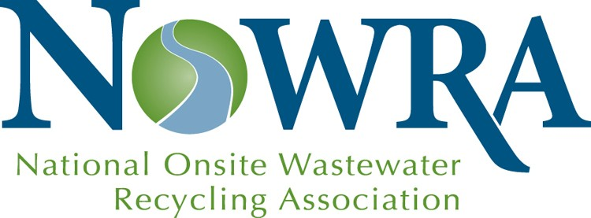

NOWRA
Corporate Membership

Increase your visibility with 5,000+ industry professionals

Corporate Membership in NOWRA is an investment that enhances your business marketing efforts while helping support the association’s mission to advance and grow the onsite and decentralized wastewater industry. NOWRA promotes the products and services of its Corporate Members to its 5,000 individual members and extends their reach to other industry professionals.

Pick the membership level that is right for you

NOWRA Corporate Membership offers levels which fit within any budget. All Corporate Memberships include:

- Multiple memberships in NOWRA for people in your company
- Discounts on exhibiting or sponsorship at the Onsite Mega-Conference
- Discounts on advertising space in the NOWRA Onsite Journal
- Free / discounted banner ads on NOWRA website
- Listing and detailed company description on NOWRA’s website
- Preferential pricing on NOWRA services
- Access to NOWRA’s Online Learning Platform
- Corporate Member sign for your exhibit booth
- Recognition as a supporter of NOWRA’s mission and goals

Corporate Membership Levels & Benefits

Item | Diamond  $8,000 | Gold $6,000 | Silver $4,000 | Bronze  $2,250 | Copper $1,000 | Pewter $500
Marketing/Membership Benefits
- 2020 Mega-Conference booth discount | $1,000 | $750 | $450 | $250 | $250 | $100
- 2020 Mega-Conference sponsor discounts | 40% | 25% | 20% | 10% | 10% | 10%
- 2020 Mega-Conference program ad discounts | 1-page  4-c ad | 1-page b/w ad | ½-page b/w ad | 20% off | 20% off | 10% off
- Company literature included in Mega-Conference tote bag | Free | Free | Free | 20% disc. | 20% disc.
- NOWRA Onsite Journal ad discounts | √ | √ | √ | √ | √ | √
- Banner ad on www.nowra.org | 1 year | 1 year | 20% off | 20% off | 20% off | 20% off
- Mailing list use | 2x/year | 1x/year | 20% off | 20% off
- Individual memberships in NOWRA | 10 | 8 | 6 | 4 | 2 | 2
- Free registration(s) to any Washington DC lobbying fly-in | 2 | 2 | 1 | 1 | 1
- 5% discount if 2020 contract paid by 12/28/19. (10% if new or upgrading Corporate Member) | √ | √ | √ | √ | √ | √
Recognition
- Listing/company overview on www.nowra.org | √ | √ | √ | √ | √ | √
- Recognition as Major Sponsor at 2020 Mega-Conference | √ | √
- Corporate Member listing in 2020 Mega-Conference program and signage | √ | √ | √ | √ | √ | √
- Corporate Member sign for your expo booth | √ | √ | √ | √ | √ | √
- Listing in NOWRA’s Onsite Journal | √ | √ | √ | √ | √ | √
- Recognition in NOWRA’s traveling trade show display | √ | √ | √ | √ | √ | √
Access to NOWRA Services
- Use of NOWRA’s Blue Sky Online Education platform for company training videos | √ | √ | √ | √ | √ | √
- Use of NOWRA’s Constant Contact broadcast email software | √ | √ | √

NOWRA
2020 Corporate Membership Contract

Company name ______________________________________________________
Address ______________________________________________________
City/State/Zip ______________________________________________________
Telephone/Fax ______________________________________________________
Website ______________________________________________________
Program Contact ___________________________ Phone: __________________
Contact E-mail ______________________________________________________

Corporate Membership Package
I wish to support NOWRA’s efforts at the following Program level:
Diamond ($8,000) Gold ($6,000) Silver ($4,000)
Bronze ($2,250) Copper ($1,000) Pewter ($500)

Payment Information
Check enclosed Credit card Visa Mastercard American Express
Credit card number ___________________________________Exp. Date ________________
Name on card (please print) _____________________________________________________
Billing Street Address ___________________________________________________________
City/State/Zip ___________________________________________________________
Authorized signature ___________________________________________________________

Additional Information Requested
Please email the following information to wecasey@comcast.net:
- Company contact for inquiries. Please provide the name, telephone and email address of the sales contact for inquiries.
Name______________________________________________________________________
Telephone__________________________ Email___________________________________
- Website address for inquiries: _________________________________________________
- Individual staff memberships. Diamond partners may select up to 10 staff for designation as NOWRA members. Gold partners receive 8 memberships; Silver-6, Bronze-4, Copper & Pewter-2). On the next page, please provide name, address, phone, and email information for each person you wish to include.

Individual staff memberships:

- Name ________________________________ Title ______________________________
Address_________________________________________________________________
Telephone_________________________ Email _________________________________

- Name ________________________________ Title ______________________________
Address_________________________________________________________________
Telephone_________________________ Email _________________________________

- Name ________________________________ Title ______________________________
Address_________________________________________________________________
Telephone_________________________ Email _________________________________

- Name ________________________________ Title ______________________________
Address_________________________________________________________________
Telephone_________________________ Email _________________________________

- Name ________________________________ Title ______________________________
Address_________________________________________________________________
Telephone_________________________ Email _________________________________

- Name ________________________________ Title ______________________________
Address_________________________________________________________________
Telephone_________________________ Email _________________________________
(Use a separate sheet for additional names)

- Company description. Please provide 300-word description of your company.
___________________________________________________________________________
___________________________________________________________________________
___________________________________________________________________________
___________________________________________________________________________
___________________________________________________________________________
___________________________________________________________________________
___________________________________________________________________________
___________________________________________________________________________
___________________________________________________________________________

Thank you! When completed, please return this form to NOWRA.
Mail: 4601 Fairfax Drive, Suite 1200, Arlington, VA 22203;
Email wecasey@comcast.net; Phone 571-242-2571; Fax: 703-997-5609

