2021 MOU Partners SepticSmart Week Social Media Guide
2021
Prepared by Partners of EPA’s Decentralized Wastewater MOU Partnership
MOU Partners’ SepticSmart Week Social Media Guide

Contents
How to Use this MOU Partnership Guide 2
What You Should Know About SepticSmart Week 2
SepticSmart Week Core Messages 2
Know Your Audience 3
Social Media for MOU Partners to Use During SepticSmart Week 3
Hashtag 3
Accounts 3
Twitter Messages 3
Facebook/ LinkedIn/ Instagram Posts 5
Website Homepages & Web Graphics 6
Blogs (Examples used in 2019) 7
Using Education to Strengthen Emergency Preparedness for Septic Systems 7
Teaming Up: How Partnerships Benefit Water Quality through Decentralized System Improvement 8
How to Guide: Governor, Mayor, Leaders and Local SepticSmart Week Proclamations 10
Monthly Planning Guide to a SepticSmart Week Proclamation 10
Other Tips and Ideas to Promote SepticSmart Week 11
Outreach Materials 12
NEW Quick Tip Videos 12
Images & Graphics 12
TV Spots 13
Press Releases, Public Service Announcements (PSAs) & Radio Advertisements 13
Press Release 13
Public Service Announcements (PSAs) 14
Radio Ads 14
Talking Points for MOU Partners 15
Personalize It! 16
Track Your Social Media Reach 16
Twitter Examples from 2019 17
Promotional Examples from 2019 17

Decentralized Wastewater MOU Partners’ SepticSmart Week Social Media Guide

How to Use this MOU Partnership Guide
Welcome! This SepticSmart Week Social Media Guide contains material and information your organization – a Decentralized Wastewater MOU Partner or affiliate of the Decentralized Program – can use to advertise and promote SepticSmart Week. In addition to the basic social media messages and outreach material, it includes tips and methods to track the information you share on your social media channels. You can copy these messages directly or customize them to reach your audience. Have fun and remember to be SepticSmart!

What You Should Know About SepticSmart Week
SepticSmart Week is an annual event focused on educating homeowners and communities on the proper care and maintenance of their septic systems. Groups from Federal, state, and local governments; the private sector; communities; and academia all participate in SepticSmart Week. You can participate too by sharing these social media messages, promoting the outreach information, and advertising SepticSmart Week.

SepticSmart Week Core Messages
- General
- Save You Money
- Safeguard Your Family’s Health
- Protect the Environment
- Protect It & Inspect It! (Day 1)
- Think at the Sink! (Day 2)
- Don’t Overload the Commode! (Day 3)
- Pump Your Tank! (Day 4)
- Don’t Strain Your Drain! (Day 5)
- Shield Your Field! (Day 6)
- Keep It Clean! (Day 7)
These are the core messages to promote during SepticSmart week using the associated social media materials, videos, and images. The MOU Partners suggest focusing on one core message and one Quick Tip per day of SepticSmart Week. Core messages and Quick Tips are available in both English and Spanish on page 12 of this guide.

Know Your Audience
One of the first things to consider with social media is identifying the audience you are trying to reach. Are you targeting professionals? Pumpers? Installers? County public health officials? Individual homeowners? Tailor your social media messages so you provide your audience with relevant tips, facts, and resources to get out the core messages of SepticSmart Week. We encourage social media posts to link to the EPA Septic website at epa.gov/septic. When sharing a link to media content such as the new Quick Tip Videos, make sure the thumbnail to the video appears underneath the post. This makes viewing the video as simple as possible (and internal to the social media platform), as opposed to opening a new window to YouTube. For Twitter, tweets can be preloaded and posted at a determined date and time using the online tools (example: Hootsuite). For Facebook, posts can be scheduled for a date and time under posting options.

Social Media MOU Partners Can Use During SepticSmart Week

Hashtag
- Official hashtag: #SepticSmart; other hashtags to consider: #Wastewater, #CleanWater, #PollutionPrevention

Accounts
- Accounts to share or engage with: @EPAwater
- Partner Twitter Accounts: @ACWAWater, @ASTHO, @ASDWAorg, @CDCgov, @ECOStates, @GWPCorg, @IAPMO, @NEHAorg, @NRWA, @NSF_Intl, @RCAPInc, @WEForg, @USWaterAlliance, @DigDeepH2O

Twitter Messages
- Remember, Twitter messages or “tweets” are 280 characters or fewer
- General tweets to be used throughout the week
  - DYK 1 in 5 U.S. homes have #septicsystems? Properly maintaining your septic system can safeguard your family’s health, protect the environment, and save you money. Learn more at https://www.epa.gov/septic
  - Costs: #SepticSystems can be a cost-effective solution to treat #wastewater for homeowners in suburban and rural communities. Learn more at https://www.epa.gov/septic
  - Public Health: Proper use of #septicsystems safeguards #publichealth by reducing the risk of harmful diseases and exposure of pathogens through drinking water. #CleanWater Learn more at https://www.epa.gov/septic
  - The Environment: #SepticSystems use gravity and natural filtration to treat #wastewater and replenish #groundwater supplies. #cleanwater. Learn more at https://www.epa.gov/septic
- One week in advance (September 13, 2021)
  - Do you have a septic system? Join us for #SepticSmart Week, Sept. 20-24! Learn how you can participate at https://www.epa.gov/septic
  - DYK 1 in 5 U.S. homes have #septicsystems? Properly maintaining your septic system can safeguard your family’s health, protect the environment, and save you money. Learn more at https://www.epa.gov/septic
  - Save the Date PDF

- Four days in advance (September 16, 2021)
  - Do Your Part. Get Septic Smart! Join us next week for #SepticSmart Week and learn septic system #QuickTips at https://www.epa.gov/septic
  - #SepticSystems treat small volumes of #wastewater from houses and businesses not served by a public #SewerSystem. Learn more at https://www.epa.gov/septic
  - Save the Date PDF

- Day 1 / September 20, 2021 / Protect It and Inspect It!
  - Today @EPAwater is kicking off #SepticSmart Week! Look for our #QuickTips to stay #SepticSmart year-round https://www.epa.gov/septic
  - DYK 1 in 5 U.S. homes have #septicsystems? Properly maintaining your septic system can safeguard your family’s health, protect the environment, and save you money. Learn more at https://www.epa.gov/septic
  - #SepticSmart #QuickTip: Protect It and Inspect It! Regular #septicsystem maintenance can save homeowners money and protect #publichealth https://www.epa.gov/septic
  - TO POST on Twitter: Protect It and Inspect It (JPEG)
  - Video to share: Protect It and Inspect It! (YouTube)

- Day 2 / September 21, 2021 / Think at the Sink!
  - #SepticSmart #QuickTip: Think at the Sink! What goes down your drain has a big impact on your #septicsystem. Get the scoop on #SepticSmart maintenance by visiting epa.gov/septic https://youtu.be/fIWoB2QtBvY
  - TO POST on Twitter: Think at the Sink (JPEG)
  - Video to share: Think at the Sink! (YouTube)

- Day 3 / September 22, 2021 / Don’t Overload the Commode!
  - #SepticSmart #QuickTip: Don't Overload the Commode! Know what should and shouldn’t go in your toilet and stay #SepticSmart at epa.gov/septic https://youtu.be/mcYAubOSEvc
  - TO POST on Twitter: Don't Overload the Commode (JPEG)
  - Video to share: Don't Overload the Commode! (YouTube)

- Day 4 / September 23, 2021 / Pump Your Tank!
  - #SepticSmart #QuickTip: Pump Your Tank! Get your #septicsystem pumped every 3-5 years to maintain its lifespan! Learn more at https://www.epa.gov/septic
  - TO POST on Twitter: Pump Your Tank (JPEG)
  - Video to share: Pump Your Tank! (YouTube)

- Day 5 / September 24, 2021 / Don’t Strain Your Drain!
  - #SepticSmart #QuickTip: Don’t Strain Your Drain! The more water you conserve, the less ends up in your septic tank. Learn more at epa.gov/septic https://youtu.be/om4mwk5VGN0
  - TO POST on Twitter: Don't Strain Your Drain (JPEG)
  - Video to share: Don't Strain Your Drain! (YouTube)

- Day 6 / September 25, 2021 / Shield Your Field!
  - #SepticSmart #QuickTip: Shield Your Field! Protect the drainfield of your #septicsystem by keeping the field free of trees, plants, and heavy objects. Learn more at epa.gov/septic https://youtu.be/Q4bTQ0PQiJA
  - TO POST on Twitter: Shield Your Field (JPEG)
  - Video to share: Shield Your Field! (YouTube)

- Day 7 / September 26, 2021 / Keep It Clean!
  - #SepticSmart #QuickTip: Keep it Clean! Test your drinking water well to keep your family healthy #CleanWater. Learn more at epa.gov/septic https://youtu.be/Tz6wx8kmr_A
  - TO POST on Twitter: Keep it Clean (JPEG)
  - Video to share: Keep it Clean! (YouTube)

Facebook/ LinkedIn/ Instagram Posts
- One week in advance: (September 13, 2021):
  - Did you know one in five U.S. homes have septic systems? Yours may be one of them. Next week we are kicking off #SepticSmart Week to encourage homeowner education and awareness. Learn more about the public health, environmental, and economic benefits of a well-maintained septic system at www.epa/gov/septic
  - Save the Date PDF

- Four days in advance: (September 16, 2021):
  - Mark your calendars for the start of #SepticSmart Week, Sept. 20-24. Do Your Part. Get Septic Smart! https://www.epa.gov/septic
  - Save the Date PDF

- Day 1 / September 20, 2021 / Protect It and Inspect It!
  - Today we're kicking off #SepticSmart Week! This week we recognize the importance of properly caring for and maintaining your septic system. Check in every day for #SepticSmart Quick Tips and learn more at https://www.epa.gov/septic
  - Protect It and Inspect It! You can help protect the environment and public health by having your septic system regularly serviced every 1-3 years. Learn more about staying #SepticSmart at https://www.epa.gov/septic
  - TO POST on Facebook: Protect It and Inspect It (JPEG)
  - Video to share: Protect It and Inspect It! (YouTube)

- Day 2 / September 21, 2021 / Think at the Sink!
  - Think at the sink! Use water efficiently to maintain the life of your septic system. Limit the use of your garbage disposal and avoid rinsing coffee grounds or pouring grease into the sink. Get the scoop on how to stay #SepticSmart at https://www.epa.gov/septic
  - TO POST on Facebook: Think at the Sink (JPEG)
  - Video to share: Think at the Sink! (YouTube)

- Day 3 / September 22, 2021 / Don’t Overload the Commode!
  - Don’t Overload the Commode! Your toilet is not a trashcan, flushing non-degradable products can clog your system and cause sewage to back up into your home or flood your yard. Do not flush anything besides human waste and toilet paper. Read more #SepticSmart tips at https://www.epa.gov/septic
  - TO POST on Facebook: Don't Overload the Commode (JPEG)
  - Video to share: Don't Overload the Commode! (YouTube)

- Day 4 / September 23, 2021 / Pump Your Tank!
  - Pump Your Tank! Did you know a typical septic tank needs to be pumped every 3 – 5 years on average? Properly caring for a septic system can be challenging if you’ve never owned a septic system before. With Septic Sam’s Top 10 List, learn easy tips to help prolong the life of your septic system. Check out our toolkit at https://www.epa.gov/septic/septic-systems-outreach-toolkit
  - TO POST on Facebook: Pump Your Tank (JPEG)
  - Video to share: Pump Your Tank! (YouTube)

- Day 5 / September 24, 2021 / Don’t Strain Your Drain!
  - Don’t Strain Your Drain! Putting the wrong items into your septic system can put the health of your family and neighbors at risk and result in expensive repairs for your system. Learn what should and should not go down your drain and stay #SepticSmart https://www.epa.gov/septic
  - TO POST on Facebook: Don't Strain Your Drain (JPEG)
  - Video to share: Don't Strain Your Drain! (YouTube)

- Day 6 / September 25, 2021 / Shield Your Field!
  - Shield Your Field! Love gardening? Your septic system does not! Be careful where you plant as roots can clog the stone and damage the pipes in your drainfield. Parking your car or placing heavy objects on top of your drainfield can also damage it. Learn how to shield your field and be #SepticSmart by visiting https://www.epa.gov/septic
  - TO POST on Facebook: Shield Your Field (JPEG)
  - Video to share: Shield Your Field! (YouTube)

- Day 7 / September 26, 2021 / Keep It Clean!
  - Keep it Clean! Properly maintaining your septic system helps to prevent contamination to your drinking water well. Test the cleanliness of your well water regularly to keep your family healthy. Learn more #SepticSmart tips at https://www.epa.gov/septic
  - TO POST on Facebook: Keep it Clean (JPEG)
  - Video to share: Keep it Clean! (YouTube)

Website Homepages & Web Graphics
- Include the “Save-the-Date” flyer on the homepage of your website
  - 2021 SSW Save the Date Flyer
- Download the SepticSmart Week 2021 seal
  - 2021 SepticSmart Week Seal
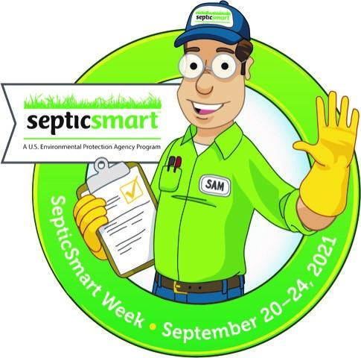

- Download the SepticSmart Week generic seal (no dates)
  - SepticSmart Week Seal (no dates)
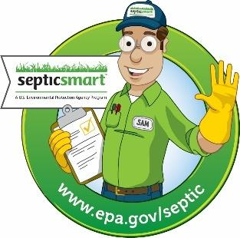

Blogs (Examples of blog posts used in 2019)

NEW! Case Study: Exceptional Efforts to Increase Awareness of Septic Systems in Whatcom County, Washington
Located in the northwest of Washington State with the Canadian border to the north and the Salish Sea to the west, Whatcom County is known for their rich water-intensive resources such as their aquaculture of shellfish and agriculture of raspberries. Therefore, protecting waterbodies and watersheds have been a top priority.
With more than 28,000 total septic systems, including 20,000 septic systems on sensitive areas along the coast and on the Lake Whatcom watershed, the county worked with seven coordinating partners who represent local municipalities to undertake a multi-year innovative campaign. The goal was to dramatically increase awareness of septic systems and to encourage best management practices for homeowners, utilizing SepticSmart Week and Clean Water Week to amplify their message.
- Assessment: The County utilized surveys and interviews to establish a baseline of the residents’ understanding of septic systems.
- Initiatives: This step helped inform the creation of communications outreach such as a press release, postcards, social media posts, and radio ads. The County also hosted events such as homeowners workshops and a public viewing of the feature film Mr. Toilet, a documentary on global sanitation.
- Evaluation: These efforts proved to have effectively increased awareness based on workshop attendance, responses from a follow-up survey, and increased website traffic.
In addition to the coordinated messaging approach, the County focused on leveraging federal, state, and local funding sources, and increasing water quality monitoring capacity. For more information about Whatcom County’s campaign, visit the County’s website.

Using Education to Strengthen Emergency Preparedness for Septic Systems
National Environmental Health Association (NEHA)
After the events of the past year, emergency preparedness has clearly emerged as one of the most important topics facing environmental health. The 2017 hurricane season left hundreds of billions of dollars-worth of damage in its wake. Meanwhile, wildfires in California burned over 1.2 million acres, resulting in five of the 20 most destructive fires in the state’s history. Despite the expansive media coverage these disasters generated, damage to wastewater treatment systems, especially private ones, was rarely discussed. Over 20% of U.S. households rely on a septic system, making them a key component to how wastewater is treated in this country. Septic systems can be damaged by hurricanes, wildfires, and a range of other disasters. Under flooded conditions, septic tanks can become dislodged and float out of the ground, heavy firefighting equipment can damage drain fields, and earthquakes can lead to drinking water contamination if septic tanks or pipes are damaged.
Including septic systems in preparedness efforts is essential to a strong recovery. Local and state health departments can provide guidance to septic system users in their communities and help residents identify qualified professionals if any repairs are needed. The best resource homeowners have, however, might be one they haven't considered: themselves. Being well versed with their septic system type, location, and components will help homeowners understand how different disaster events might impact their systems. Recognizing warning signs after a disaster and knowing when to call a licensed professional will also save homeowners from costly repairs down the road and protect their families' health. Taking steps to care for one's septic system, such as being mindful of what goes down the drain or keeping cars off the drain field, will also help systems function during and recover after a disaster hits.
From the national to the local level, more can and needs to be done to incorporate septic systems into emergency preparedness planning. While counties, states, and even federal agencies can grow their programs in this area, homeowners are best armed with a thorough understanding of how their system operates and who they should contact when something goes wrong. Unfortunately, years fraught with disaster events like 2017 are likely to become more frequent. Raging hurricane and wildfire seasons may strike again, and other disasters affecting septic systems will likely return. Building capacity at the state and local level is critical, but homeowner education is necessary to creating an efficient emergency preparedness program for septic systems.
Check out some of the free educational resources below to get started.
Environmental Protection Agency: https://www.epa.gov/septic
National Onsite Wastewater Recycling Association: http://septiclocator.org/

How to Guide: Governor, Mayor, Leaders, and Local SepticSmart Week Proclamations
SepticSmart Week typically takes place on the third week of September every year. This annual event focuses on educating homeowners and communities on the proper care and maintenance of their septic systems, as well as protecting public health, the environment, and one’s property value. To make the most of SepticSmart Week, EPA and the Decentralized Wastewater MOU Partnership developed numerous outreach materials and resources, which are available at https://www.epa.gov/septic/septic-systems-outreach-toolkit.

The SepticSmart Week Proclamation is a popular resource available in the toolkit. This proclamation is a one-page declaration that shows support for SepticSmart Week. Proclamations can be issued by governors, mayors, local health or environment department leaders, MOU partner organization leaders, affiliate organization leaders, community organization leaders, and more. The proclamation templates are customizable. We hope that proclamations can be issued at the start of SepticSmart Week; however, we will accept them anytime! The show of support is what matters most.

SepticSmart Week Proclamation Templates
- SepticSmart Week Proclamation for Governors (WORD)
- SepticSmart Week Proclamation for Mayors (WORD)
- SepticSmart Week Proclamation for Leaders (WORD)
- SepticSmart Week Proclamation for Decentralized Wastewater MOU Partners (WORD)

Monthly Planning Guide to a SepticSmart Week Proclamation

MONTH | STEPS | IMPORTANT NOTES
May | - Begin gathering information  - Create a timeline | - Start early!
June | - Identify any established procedures around securing a proclamation  - Ensure you have leadership support and make sure that is communicated in each step  - Develop the wording for the proclamation (see EPA sample proclamations)  - Draft memo from agency head to your state’s appointed health official (i.e. Secretary of Health, Surgeon General, etc.)  - Draft memo from Health Official to Governor’s Office | - Save email from your leadership approving initiative as your Governor’s Office may ask for it  - Make sure wording is short and to the point  - Explain how it will benefit communities  - Make sure the proclamation is in Microsoft Word for easy editing  - Write the Governor’s Proclamation yourself in plain text, without any formatting. This makes it easy for the Governor’s Office to simply use your draft and add on their Governor Proclamation formatting  - Check out examples of previous years’ proclamations (https://www.epa.gov/septic/septicsmart-week-2017-proclamations)
July | - Enlist support from other state/local health departments  - Identify a point person in the process, whether at the State Health Department or Governor’s Office that you can check in with | - Keeping in touch will help you to know the status of your request and if there is anything missing that you need to submit  - Knowing this early on is important so that you do not run out of time to make corrections or additions  - Follow up with emails and phone calls  - Ensure memos are sent from agency head to health official
August | - When you receive your proclamation, SHARE IT! Share it at local events, social media posts and news releases | - The proclamation gets posted on the governor’s webpage, bringing more attention to your cause  - The proclamation adds more weight to your social media posts and increases the chance of it being picked up and shared across wider audiences
September | - Share! Share! Share!  - Measure your impact! | - Metrics matter! As much as possible, identify the impact of your outreach activities.  - Connect with partners to measure impact  - Are calls regarding septic system operation and maintenance increasing?  - Are local health departments seeing an increase in calls?

Other Tips and Ideas to Promote SepticSmart Week
- Take full advantage of the materials provided by EPA. These materials can be modified to fit your unique community regulations and needs. Your jurisdictional contact information can also be added.
- Nearly all EPA SepticSmart outreach materials have been translated into the Spanish language. We encourage users to utilize these materials when communicating to predominantly Spanish-speaking communities.
- Share information with other jurisdictions as early as possible so they can have time to add it to their outreach calendar.
- Create partnerships with industry to promote SepticSmart Week and share informational flyers. Some septic system service providers have offered a discount for services booked during SepticSmart Week creating a win-win situation. This works well in the Val-Pack coupon mailers.
- Bus ads and billboards can be used throughout the state and reach a lot of people.
- Reach out to other agencies for opportunities to share information. Some ideas include:
- Highway signs or other “outdoor” advertising
- Permitting/Inspection
- Look within the health department for other outlets:
- Public Health Nurse home visits
- Healthy home inspections
- Restaurant inspections for establishments that rely on septic

Outreach Materials
- Quick tips, flyers, website graphics, postcards, brochures, mail inserts, guides, and door hangers can be found on EPA's Septic Systems Outreach Toolkit
- The Do's and Don'ts of Your Septic System – popular downloadable graphic

NEW Quick Tip Videos
- Share videos for the following Quick Tips!
- Link for all videos: https://www.epa.gov/septic/septicsmart-week-quick-tip-videos, or individually:
  - Think at the Sink!
  - Don't Strain Your Drain!
  - Keep it Clean!
  - Shield Your Field!
  - Don't Overload the Commode!
  - Pump Your Tank!
  - Protect It and Inspect It!

Images & Graphics
- Use pictures to tell the story!
- Photos or images associated with each of the SepticSmart Week Quick Tips:
  - Think at the Sink! English version │ Spanish version
  - Don't Strain Your Drain! ​English version │ Spanish version
  - Keep It Clean! English version │ Spanish version
  - Shield Your Field! English version │ Spanish version
  - Protect It and Inspect It! English version │ Spanish version
  - Don't Overload the Commode! English version │ Spanish version
  - Pump Your Tank! English version │ Spanish version
- Use the home infographic with core SepticSmart messages:
  - Do Your Part Infographic

TV Spots
- Local news stations, interviews, promoting SepticSmart Week
  - WTAT News - South Carolina News Station
    - 9-minute interview with local expert promoting awareness for SepticSmart Week in South Carolina (from 2017)

Press Releases, Public Service Announcements (PSAs) & Radio Advertisements

Press Release
FOR IMMEDIATE RELEASE Contact: XXXXXXXXX
(XXX) XXX-XXXX
xxxxxxxxx@xxxx.com
EPA’s Ninth Annual SepticSmart Week: Safeguard Your Family’s Health, Protect the Environment, and Save Money
Washington, D.C. (Sept. X, 2021) — The U.S. Environmental Protection Agency (EPA), supported by state and local governments, the private sector, communities, and academia, will sponsor its eighth SepticSmart Week 2021, Sept. 20-24, an annual event focused on educating homeowners and communities on the proper care and maintenance of their septic systems.
More than one-fifth of U.S. households utilize an individual onsite system or small community cluster septic system to treat their wastewater. These systems treat and dispose of relatively small volumes of wastewater and include a wide range of individual and cluster treatment options to process household and commercial sewage. These systems go by such names as septic, decentralized wastewater treatment, cluster, package plants, on-lot, individual sewage disposal, and private sewage.
Onsite systems provide a cost-effective, long-term option for treating wastewater, particularly in sparsely populated areas. When properly installed, operated, and maintained, these systems help protect public health, preserve valuable water resources, and maintain a community’s economic vitality.
EPA’s SepticSmart initiative is a nationwide public education effort offering educational resources to homeowners, local organizations, and government leaders to explain how septic systems work and provide tips on how to properly maintain them. Organizations and individuals wishing to promote SepticSmart Week 2021 are encouraged to create public awareness about the event and share helpful tips, such as:
  - Think at the Sink!: What goes down the drain has a big impact on your septic system. Fats, grease, and solids can clog a system’s pipes and drainfield.
  - Don’t Overload the Commode!: A toilet is not a trash can. Disposable diapers and wipes, feminine hygiene products, coffee grounds, cigarette butts, and cat litter can damage a septic system.
  - Don’t Strain Your Drain!: Use water efficiently and stagger use of water-based appliances. Too much water use at once can overload a system that hasn’t been pumped recently.
  - Shield Your Field!: Tree and shrub roots, cars, and livestock can damage your septic drainfield.
  - Keep It Clean!: Contamination can occur when a septic system leaks due to improper maintenance. Be sure your drinking water is safe to drink by testing it regularly.
  - Protect It and Inspect It!: Regular septic system maintenance can save homeowners thousands of dollars in repairs and protect public health.
  - Pump Your Tank!: Ensure your septic tank is pumped at regularly intervals as recommended by a professional and/or local permitting authority.
SepticSmart Week 2021 encourages homeowners, wastewater professionals, and state, tribal, and local officials to design and maintain effective systems to safeguard your family’s health, protect the environment, and save money. Be part of the solution by visiting www.epa.gov/septic for an abundance of resources and information.

Public Service Announcements (PSAs)
- Septic Sam says ‘Save the Date’. SepticSmart Week is September 20th through the 24th. Each year EPA holds SepticSmart Week with outreach activities to encourage homeowners and communities to care for and maintain their septic systems. You wouldn’t drink out of your toilet would you? That is why information about maintenance and care is so important to help keep our water resources and our environment clean and safe. Septic Sam says call xxx-xxx-xxxx to learn more or go to [insert agency website].

- Septic Sam says ‘Do Your Part, Be SepticSmart’! Learn more about septic system care and maintenance during SepticSmart Week, September 20th through the 24th. Each year the EPA uses SepticSmart Week to reach out to homeowners and communities, to care for and maintain their septic systems. You wouldn’t drink out of your toilet would you? That’s why information about your septic system is vital in helping to prevent pollution and contamination of our environment and water resources. Call xxx-xxx-xxxx or go to [insert agency website].

Radio Ads
- If you’re buying a home in [insert State] you might be purchasing a septic system as well. Septic systems are effective and easy to maintain, but failing systems are a major cause of water pollution and can be expensive to replace. Learn the warning signs including slowly draining sinks, and toilets, or sewage odors in the house or yard. Better yet, get a professional to inspect your system, determine the age of the system, and make sure that it is properly sized for your current needs. Please check with local authorities for additional requirements in your area. This message is brought to you by [insert agency name].

- Out of sight and out of mind… Does that describe your relationship with your septic system? Proper maintenance of your septic system will affect how well it works, and, how long it lasts. And the most important part of maintenance is a regular inspection. Don’t wait until there’s a problem. Inspections will catch problems before they become serious and expensive to correct. The results can also suggest simple lifestyle changes such as conserving water. That will extend the life of your system. To learn more about your septic system, call your local [insert agency] office and request any materials designed especially for homeowners with septic systems. Protect your property, your family, and the environment, by getting to know your septic system. Please check with local authorities for additional requirements and recommendations in your area. This message is brought to you by [insert agency name].

- If you’re like most homeowners, you don’t think about what happens to things that go down the drain. But if you have a septic system, those things can come back to haunt you. Several things can damage your septic system and cause unpleasant and expensive problems. Don’t use your toilet as a trashcan… unless you want those items back. Call [insert agency name] to learn more about your septic system before it’s too late. Protect your property, your family, and your neighbors by getting to know your septic system. This message is brought to you by [insert agency name].

Talking Points for MOU Partners
- “SepticSmart Week is an important event in our community which reminds homeowners to maintain their septic systems. A well-managed septic system protects the health of the homeowner, as well as their neighbors and the community. Those who participate in SepticSmart Week should be commended.”

- “SepticSmart Week is an important step in raising awareness about septic systems and maintenance in our community. This campaign brings community members together and fosters good stewardship. Septic maintenance helps the community avoid costly repairs, maintain home property values, and protect local water sources.”

- “SepticSmart Week generates revenue for small businesses - septic installers, manufacturers and service providers. This small business growth supports local economies, jobs and families.”

- “[Organization name] is proud to participate in SepticSmart Week 2021. Proper septic maintenance and care is essential to protecting the property, health, and environment of our community(ies). We hope that homeowners take a moment this week to schedule service they may have put off and follow septic maintenance best practices.”

Personalize It!
- Some of the brochures, pamphlets, and postcards on www.epa.gov/septic have white space on the front page to place your business card or use with a mailing label
- Use these existing materials and add your own personalized mailing label or company logo.
  - Homeowner's Brochure
  - Homebuyer’s Guide
  - Spring Postcard

NEW! COVID-19 and Wastewater Safety and Health Resources
*Due to the 2020 COVID-19 Pandemic, below is a sample of resources from federal agencies and organizations involved in the MOU partnership.

Coronavirus and Drinking Water and Wastewater
Webpage from EPA
There is no higher priority for EPA than protecting the health and safety of Americans. EPA is providing this important information about COVID-19 as it relates to drinking water and wastewater to provide clarity to the public. The COVID-19 virus has not been detected in drinking-water supplies. Based on current evidence, the risk to water supplies is low. Americans can continue to use and drink water from their tap as usual. EPA also encourages the public to help keep household plumbing and our nation’s water infrastructure operating properly by only flushing toilet paper. Disinfecting wipes and other items should be disposed of in the trash, not the toilet.
EPA Administrator Andrew Wheeler sent a letter to Governors in all 50 states, territories, tribes and Washington, DC, requesting that water and wastewater workers, as well as the manufacturers and suppliers who provide vital services and materials to the water sector, are considered essential workers and businesses by state authorities when enacting restrictions to curb the spread of COVID-19. Our critical water infrastructure and its operators ensure the safe supply of water to our homes and hospitals, and depend on treatment chemicals, laboratory supplies and related goods and materials. Read letters to local leaders from Administrator Wheeler about the importance of water and wastewater services.
The Agency has provided a template that states, tribes, localities, water utilities and technical assistance providers can use to provide documentation to workers that are considered essential: Water Utility Template: COVID-19 Pandemic or Water Utility Template for Tribal Lands: COVID-19 Pandemic.
EPA also supports states and cities that have already taken proactive measures to ensure continued access to clean water for drinking and handwashing during the COVID- 19 pandemic. Many drinking water systems are discontinuing service cut-offs, restoring service to customers whose service was previously cut-off, and refraining from imposing penalties for nonpayment. EPA recommends widespread adoption of these practices, which provide critical support for public health.
Additional Information
- Frequent questions related to coronavirus (COVID-19) and drinking water and wastewater
- Water utility resources for the COVID-19 pandemic
- Tribal water utility resources for the COVID-19 pandemic

Information for Sanitation and Wastewater Workers on COVID-19
Webpage information from CDC
Recently, the virus that causes COVID-19 has been found in untreated wastewater. While data are limited, there is no information to date that anyone has become sick with COVID-19 because of exposure to wastewater.
Standard practices associated with wastewater treatment plant operations should be sufficient to protect wastewater workers from the virus that causes COVID-19. These standard practices can include engineering and administrative controls, hygiene precautions, specific safe work practices, and personal protective equipment (PPE) normally required when handling untreated wastewater. No additional COVID-19–specific protections are recommended for workers involved in wastewater management, including those at wastewater treatment facilities.
More Information
- CDC: Guidance for reducing health risks to workers handling human waste or sewage
- CDC: Water and COVID FAQs
- CDC: Sanitation and Wastewater
- CDC: Waste Management
- Occupational Safety and Health Administration: COVID-19 Control and Prevention: Solid waste and wastewater management workers and employers

NOWRA, Onsite Wastewater and the Coronavirus Outbreak
Webpage information from NOWRA
As the coronavirus (COVID-19) outbreak continues to escalate around the world and the US, NOWRA is providing up-to-date information to help you address the many ways this pandemic is affecting you and your organization. Please know that the safety of our members and the entire onsite wastewater community is our primary concern, but we also want to provide you with resources which will help you continue your business.

More Information
- NOWRA Programs/Activities
- Federal Loan and Tax Relief Programs
- Your Business Operations
- Government Policies

PSA on Flushable Wipes During COVID-19
PSA from Sara Heger, NOWRA

NPR’s Here & Now host Jeremy Hobson talks to Sara Heger, a wastewater expert at the University of Minnesota, about one side-effect of the rise in household cleaning as a result of the coronavirus: More people are clogging wastewater treatment systems with erroneously labeled "flushable" wipes.

COVID-19 Guidance and Resources
Webpage information from WRF

With the COVID-19 pandemic spreading worldwide, The Water Research Foundation has been dedicated to keeping water sector professionals informed about this virus and any measures needed to protect both water sector workers and public health. WRF continues to gather key information from experts in the fields of infectious disease control, virology, water engineering, outbreak epidemiology, pandemic trends, and risk emergency response, and provide deliverables and learning opportunities to disseminate the latest information.

Evaluation
Evaluation is a critical component for understanding the success, reach, and impact of social media engagement. It helps identify the audience and whether the message has increased their awareness. Feedback can also be used to inform future decision-making.
Below is a list of quantitative and qualitative measurable actions the program can measure, track, and document to develop an evaluation summary.
Social Media (See below for how to track your social media presence)
- Total Reach and Impressions
- Total Likes and Shares
Other Engagement
- Survey participation
- Attendance of workshop or training
- Website traffic

Track Your Social Media Reach
- Keep track of your social media efforts so you can report out on who you reached. As an MOU partner, it is extremely helpful for all of us to know the extent of our individual and collective efforts to send the SepticSmart message.
- Free social media trackers are available to identify audience, reach, and how well a message is received (a few examples below). Then you can report back to the other partners with your results!
  - Google Analytics
    - Tracks user activity on your website in real-time, such as: daily site visits, demographics of users, how they reached your site, how long they stay on your site, and which parts of your website are most and least popular.
  - Hootsuite
    - Measures social media ROI from all platforms in one place. The free version allows for 1 user and 3 social media platforms). A free 30-day trial for some advanced features is also available.
  - Facebook and Twitter Insights
- Metrics:
  - First identify your “Call to Action.” Are you trying to get people to go to your website? Are you trying to get people to share your post?
  - Second, identify the appropriate metric to use based on your call to action:
    - Measuring awareness: how far is your message spreading (volume, reach, exposure, amplification)
    - Measuring engagement: how many people are participating, how often and in what forms are they participating (likes, retweets, comments, replies, and participants)
    - Measuring traffic: are people moving though social media to your external site, and what do they do on your site (track URL shares, clicks, and conversions)
  - Third, analyze the buzz you are creating.
    - Use the tools above or generic tools such as:
      - Social Mention: real-time social media search and analysis that tracks user sentiment, top keywords and users, hashtags, and sources of your search word. Type in a word, such as “septic system” to search its mention online

Twitter Examples from 2019
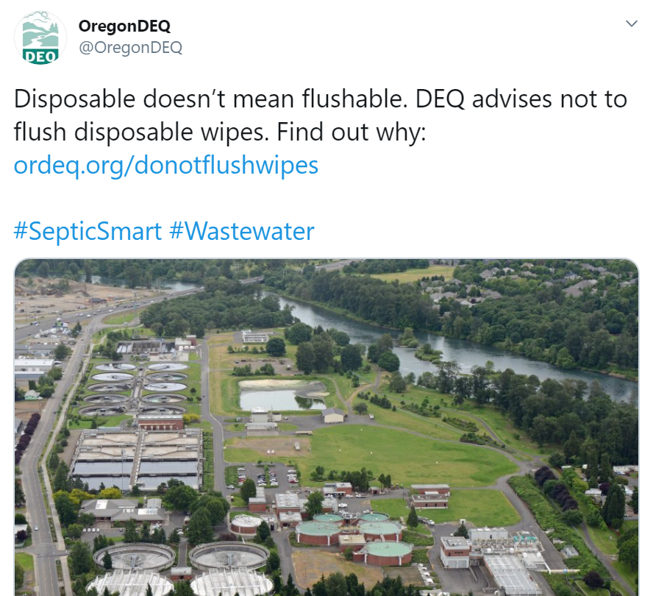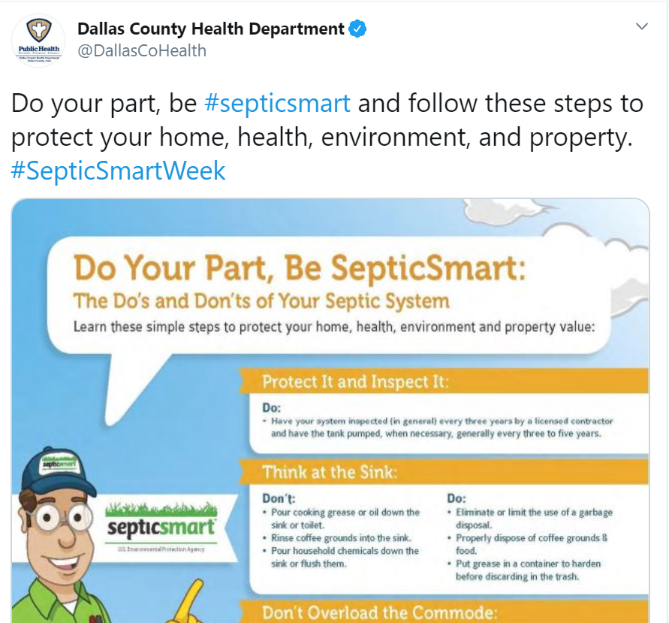
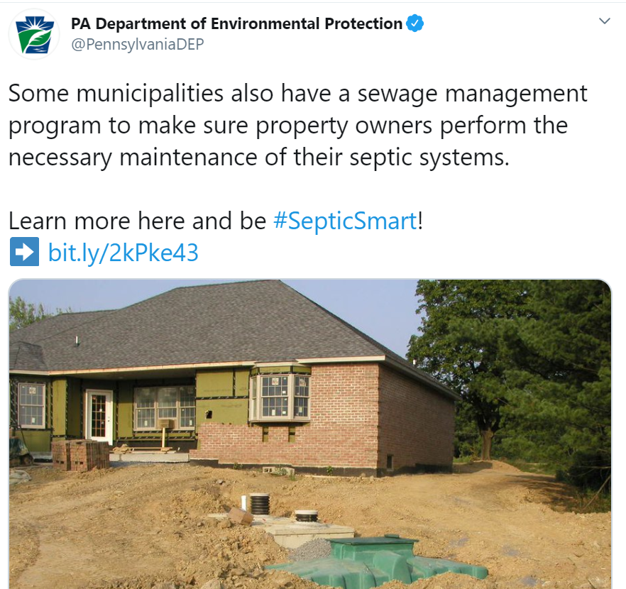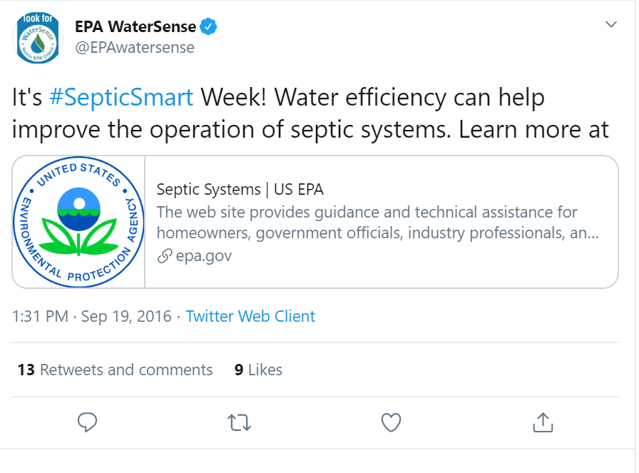

Promotional Examples from 2019
- Vermont Public Radio broadcast "Talking Dirty: Discussing Your Septic System" featuring SORA’s president, Mary Clark (Vermont Dept of Environmental Conservation)

- The below images are from Kristine Rendon, Dave Cotton, and Dale Ladouceur, Michigan DEQ Onsite Wastewater Program

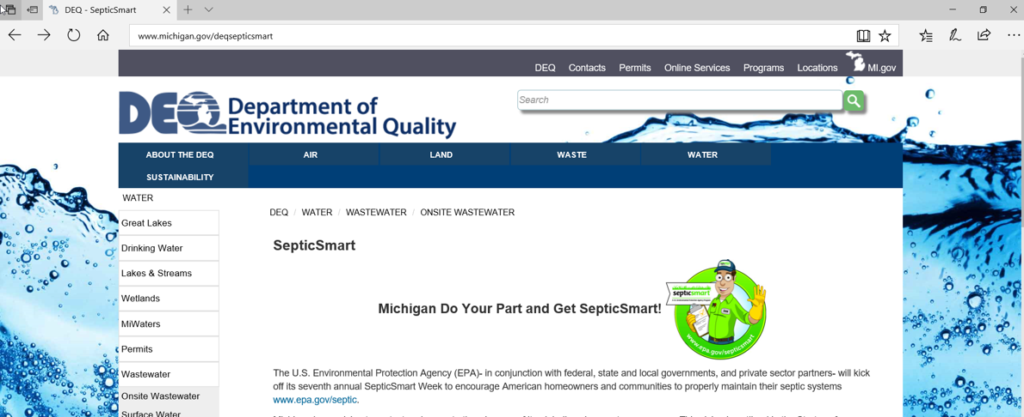
Image: Advertising on state DEQ website
Image: Presentations across the state educating those on what it means to be SepticSmart (pictured – Dave Cotton holding hands-on training on septic systems)

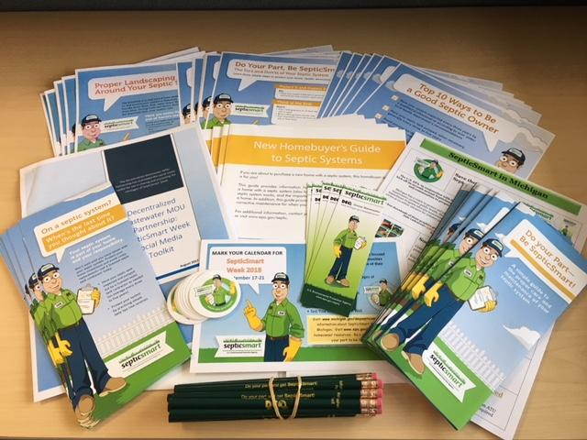
Image: Printed flyers and promotional material

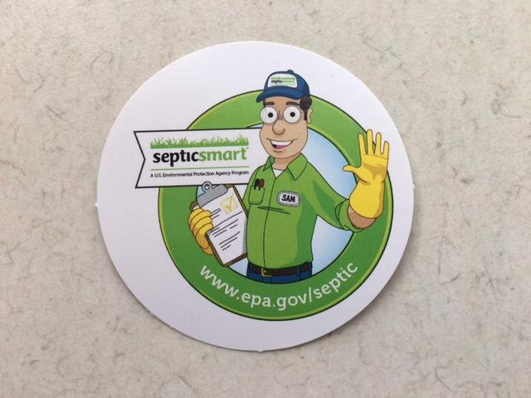
Image: Promotional stickers

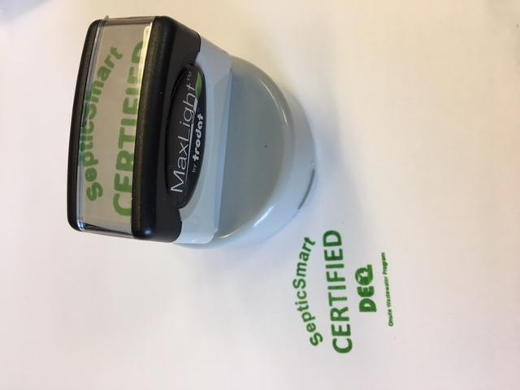
Image: SepticSmart “certified” stamp

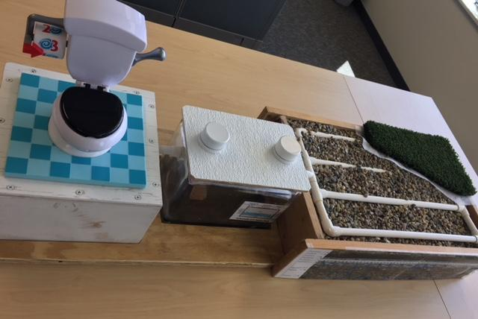
Image: Kid-friendly education/ interactive septic system

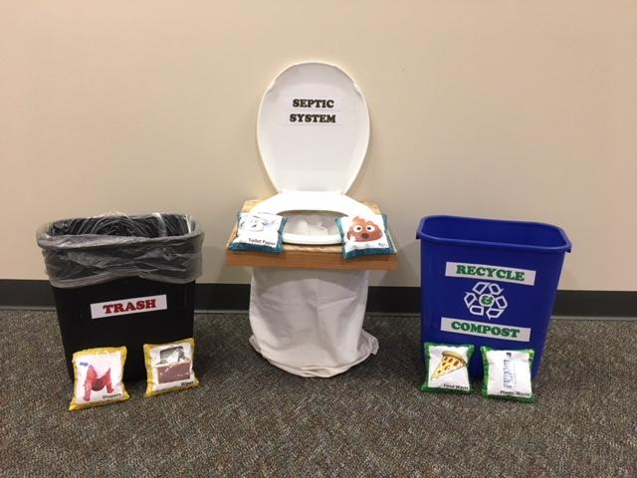
Image: “Not in my septic system” bean bag game

