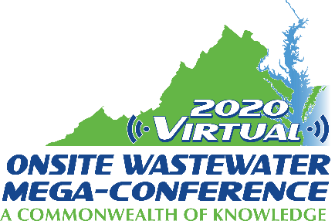

Mini-Track Session Descriptions
2020 Virtual Onsite Wastewater Mega-Conference

COVID-19 and Wastewater
Tuesday, November 17, 2020 – 9:00 am – 12:00 pm

Session title: Impacts of COVID-19 on the Decentralized Industry (1 hour)
Presenter: Sara Heger
The current global coronavirus crisis caused by SARS-CoV2, or COVID-19 has highlighted the interconnectedness of our planet in ways that were underappreciated by the average American until recently. There are numerous issues that have arisen related to septic systems in relation to COVID-19. The first relates to worker safety. As the epidemic began there was concern for those working around wastewater and access to appropriate personal protective equipment. Question arose to the treatment of COVID-19 through large to small wastewater treatment systems. Another large issue that arose related to the financial impact to small business across our industry. Then there was the shifting of wastewater production as sheltering in place spread across the United States many people shifted towards using home offices, home schooling and generally spent mush more time at home and increased their load to their system. At the same time the use of sanitary wipes and other sanitizing products increased due to heightened safety concerns. This presentation will discuss the short- and long-term potential impacts of these issues.

Session title: Panel Discussion: Just One More Worry – Perspectives on Dealing with COVID on the Job (2 hours)
Presenter: Cindy Tiemann, Panel chair
The wastewater industry is no stranger to dealing with issues that affect how their businesses operate. Some of these issues can be related to weather, seasons/climate, the economy, the labor market, local rules and regulations, state and federal mandates to name just a few. This year the continent is not only being hit with horrible storms and fires but the world has also been hit with a Pandemic that is turning 2020 into the year that many businesses may end up calling their last year in business. Its yet one more Worry…
For this session today, we have gathered a group of 11 Wastewater owner/operators from across the US and Canada to discuss all of the issues they dealt with and continue to encounter during this Pandemic. We will discuss their thoughts on being termed "Essential Workers" for the first time ever. What were their initial and ongoing thoughts and fears as they made decisions for their companies, knowing every decision they made could very well affect, not only themselves but their entire Business, Person in their Family and every employee as they steered them all into the eye of this Pandemic Storm, while not knowing being able to visualize the final destination. Did they change course based on any association recommendations or was it simply business as usual? Were there course changes due to State or requirements or were they proactive on creating their own precautions for their business? Were there any personal issues that came up along the way that made them change their course? Zoom with us as we listen to these wastewater operators from all over this vast continent talk to each other about their thoughts, hopes and decision making processes as they relate to their concerns about this pandemic and the wastewater industry and profession as a whole. Are they worried about the future? What are their plans? What if any are their projections for their businesses and this profession moving forward?
From this conversation you will be able to see just how different each part of this continent is from their perspective and how people really do think and act differently in each part of it……OR do they?
Panelists:
- Cindy Tiemann – Fiedler Your Pumping Specialists, Inc- Royalton, Minnesota
- Morgan McAtee – McAtee Company, Inc – New Gloucester, Maine
- Thomas Van Wart – A-1 Porta Pots and Septic Service – St. David, Arizona
- Chris Aitkin - Rankins Septic Tank Pumping & Environmental Services, Waterdown, Onterio Canada
- Ronnie Tamez First Call Septic, Battleground, Washington
- Jesus Juice Rosales Juices Septic & Grease Pumping, San Saba, Texas
- Doug McAtee McAtee Company, Inc-New Gloucester, Maine
- Clayton Foster - Acreage Development Solutions, Ltd -Millerville, Alberta, Canada
- Charlie Peloni - Peloni Pumping and Portable Toilets, Lake City Florida
- Stacy Creech – Creech’s Plumbing - Wilson, North Carolina
- Chris Scott -Scotts Septic Tank Service, LLC - Christiana, Tennessee
- Stefan Pappas - Pappas Pumping and Septic Services- Hailey, Idaho

