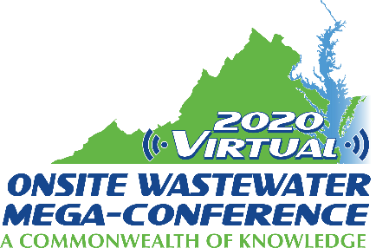

Mini-Track Session Descriptions
2020 Virtual Onsite Wastewater Mega-Conference

EPA Updates
Tuesday, November 17, 2020 – 2:00 pm – 4:00 pm

Session title: EPA's Decentralized Wastewater Program Update (30 min.)
Presenter: Heidi Faller
The U.S. Environmental Protection Agency (EPA)'s, Office of Wastewater Management (OWM), Decentralized Wastewater Program provides resources, education, and outreach at a national level for managing and maintaining decentralized wastewater systems. This presentation will highlight the major accomplishments and updates of the Decentralized Program in 2019-2020, including SepticSmart Week, and the Decentralized MOU Partnership. The Decentralized Program's annual outreach campaign, SepticSmart Week, promotes proper care and maintenance of septic systems primarily for homeowners. EPA's Decentralized Wastewater MOU Partnership, which consists of associations and experts in the decentralized field, helps to promote the messages of SepticSmart Week to their members, develop SepticSmart materials and foster outreach and education on decentralized wastewater systems. Achievements of the MOU Partnership will be presented, including highlights from the 2020 MOU Partnership renewal.

Session title: Pathways to Success for Funding Decentralized Systems with the Clean Water State Revolving Fund (30 min.)
Presenter: Naomi Huff
Approximately one in five American households rely on some type of decentralized wastewater treatment system for treatment of their home's sewage. However, the impacts of failing or inadequate systems can have negative effects on human and environmental health as well as accrue detrimental economic loss. As a means to assist individuals or communities with decentralized systems, the Environmental Protection Agency (EPA) has created a guide that will aid people in how to access economic resources and navigate the Clean Water State Revolving Fund (CWSRF). Under the CWSRF, the funding of decentralized wastewater system repair, replacement, and/or new construction are eligible projects. However, historically, many states have not utilized this source of funding for decentralized projects in their own state. This presentation will outline a step-by-step pathway to success for the decentralized community to help communicate the need to better access this source of funding at the state level, as well as include examples of state programs that have successful mechanisms in place to fund decentralized wastewater systems in their state.

Session title: EPA's Decentralized Wastewater Workforce Update (1 hour)
Presenter: Zach Lowenstein
EPA's Decentralized Wastewater Program has been addressing the challenges surrounding the decentralized wastewater workforce, such as recruitment, retention, availability of training, etc, over the past few years. Building off of the listening sessions at the 2018 Onsite Wastewater Mega-Conference, and the national meeting at the National Environmental Health Association's 2019 Annual Education Conference, EPA and the Decentralized Wastewater Workforce Steering Group have been working on materials to help address the workforce needs of the industry, primarily, through two key deliverables: 1) the mapping of career pathways by industry subset (e.g., private sector, regulatory, independent contractors, academia) that encompass the variety of occupations within that subset, including the growth projections and competencies required for each of those careers, and 2) a national scan of education and training programs, as well as identification of gaps in education and training programming to promote partnerships with education institutions that lead to sustainable programs leading to employment in the decentralized wastewater industry. This presentation will provide an overview of the key findings of the research mentioned above, as well as a discussion on next steps for workforce development for the decentralized wastewater industry.

