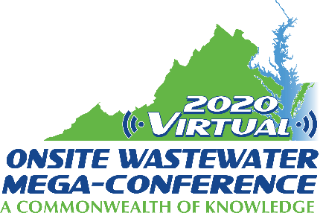

Mini-Track Session Descriptions
2020 Virtual Onsite Wastewater Mega-Conference

New Regulatory Frontiers - COVID and Reuse
Wednesday, November 18, 2020 – 9:00 am – 12:00 pm

Session title: Development of Regulations for Rainwater Harvesting Systems Incorporating Human Consumption (1 hour)
Presenter: Anthony Creech
Rainwater harvesting is a centuries-old technology providing benefits including control of surface runoff, reduction of strain on surficial aquifers, and provision of clean water. In recent years, rainwater harvesting applications in modern construction tend towards non-potable uses including irrigation and toilet/urinal supply water, and is guided primarily by building codes. The Commonwealth of Virginia in 2018 mandated development of regulations for rainwater harvesting, to include consideration of systems designated to human consumption. In response, the Virginia Department of Health assembled stakeholders to initiate the regulatory process. Rainwater harvesting for human consumption represents a potentially useful tool with respect to onsite sewage treatment, particularly in locations where small lots, private wells, and other factors limit repair options for failing systems. In areas of anticipated sea level rise, rainwater harvesting systems for human consumption represent possible means to replace water from wells damaged by inundation or salt water intrusion, particularly where public water supply systems are not an option. This presentation will summarize efforts to develop a rainwater harvesting regulation for human consumption, and identify critical components of rainwater harvesting, particularly as pertaining to decentralized wastewater systems.

Session title: Turning Human Waste into Fuel and Disinfected Water (1 hour)
Presenter: Ed Osann
Non-Sewered Sanitation Devices - A new ISO Standard for a Reinvented Toilet Delegates from Canada, the US, and some 30 other countries have been collaborating for the last two years to develop a new ISO standard for non-sewered sanitation devices. Intended to meet critical public health needs in developing countries with limited water and wastewater infrastructure, this new standard also carries important implications for water and wastewater management in North America. From national parks to suburban shopping malls, high-tech toilets meeting the new ISO standard could upend our approach to sanitation and our expectations about future water demands and water-related infrastructure. This presentation will consist of three parts: a) a brief discussion of the vision behind a â€œreinventedâ€ toilet; (b) an outline of the forthcoming ISO Standard 30500, including scope, performance requirements, and test procedures; and (c) an overview of some of the technologies and approaches that are currently in development and field testing. Participants will be challenged to consider where, in their own community, sanitation devices that require no permanent connection to water and sewer lines would fill a useful purpose.

Session title: Septic System Installation Permitting and Inspector During a Pandemic, Chris LeClair (1 hour)
Presenter: Chris LeClair
Maintaining normal permitting and inspections is crucial during this pandemic to make sure that the economy continues. This discussion will detail the subtle changes that were made in a small, northern Minnesota county during the COVID-19 pandemic to ensure that septic systems continued being permitted and inspected while at the same time ensuring the health and safety of county staff and contractors

