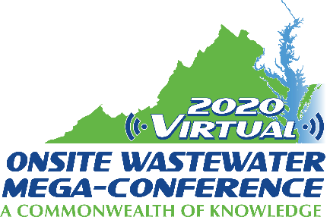

Mini-Track Session Descriptions
2020 Virtual Onsite Wastewater Mega-Conference

Nitrogen
Wednesday, November 18, 2020 – 2:00 pm – 4:00 pm

Mini Track: Nitrogen
Session title: Urine diversion for onsite removal of nitrogen and pharmaceuticals (1 hour)
Presenter: Abraham Noe-Hays
Urine diversion is an alternative to advanced onsite treatment that can remove nutrients and pharmaceuticals with lower cost, less site disruption, and lower electricity consumption, while producing a valuable fertilizer. Rather than combining all domestic wastes into one stream and then treating the entire dilute volume, the source separation of urine eliminates the great majority of nutrients and about half the pharmaceuticals before they even enter the mix. The urine is collected using commercially-available urinals or urine-diverting toilets, which are plumbed to onsite storage tanks. In existing pilot installations, urine is then collected twice a year by pumper truck, treated at a central facility, and delivered to farms for use as fertilizer. Researchers at the Rich Earth Institute and the University of Michigan are currently testing an onsite treatment system that uses freeze concentration and pasteurization to produce a small volume of sanitized fertilizer that is suitable for direct use without further treatment. This innovation will enable urine diversion systems to be installed and operated independently of any larger processing infrastructure. This ongoing project is conducted using two real-world test platforms: public restrooms at the University of Michigan with urine-diverting fixtures connected to an experimental processing facility, and the Rich Earth Institute's community-scale Urine Nutrient Reclamation Program in Vermont.

Session title: Basic Nitrogen Treatment Principles in Wastewater Systems with Blodgett Landing Case Study (1 hour)
Presenter: Dave Lentz
Have you ever wondered how nitrogen in domestic wastewater is biodegraded in an onsite wastewater treatment system? The nitrogen cycle plays a key role in nitrogen removal from domestic wastewater, requiring specialized processes and equipment to complete the treatment process. Part 1 of this presentation uses a multi-media format to cover the elemental steps required to complete the decomposition pathway within an onsite wastewater treatment system. Discussion topics include the basic elements of wastewater chemistry, microbes, and chemical treatment processes. The session will begin with an informative video on the nitrogen cycle, followed by an explanation of the associated nitrification and denitrification concepts, and end with an interactive quiz-show game that will put your nitrogen-cycle knowledge to the test. Part 2 covers a real-life example from Blodgett Landing, New Hampshire.

