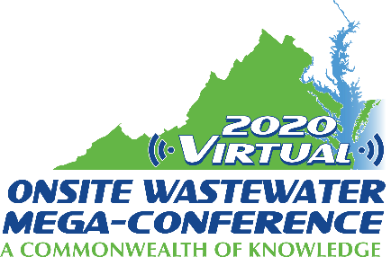

Mini-Track Session Descriptions
2020 Virtual Onsite Wastewater Mega-Conference

Planning
Monday, November 16, 2020 – 2:00 pm – 4:00 pm

Session title: Planning for Sustainability: Case Studies for Improved Wastewater Decision-Making (1 hour)
Presenter: Victor D'Amato
As communities shift their water quality protection efforts to focus on non-point sources of pollutants, sewering of properties on septic systems 'septic-to-sewer programs' are increasing in frequency and magnitude. At the same time, decentralized water practitioners continue to develop approaches and technologies that address real and perceived shortcomings of septic systems, and mainstream water professionals espouse decentralized 'One Water' approaches, including building-scale water reuse systems in urban areas. Clearly, onsite wastewater management can be reliable, sustainable and cost-effective in a variety of geographies and contexts. This paper will demonstrate robust processes for wastewater management decision-making using case studies. The Delaware Department of Natural Resources and Environmental Conservation sponsored an analysis that compared costs of centralized and decentralized alternatives for water and sewer in select underserved areas. Maryland Department of Environment completed a data mining, management and analysis effort that rated potential upgrades to campground and mobile home park wastewater systems to help comply with Chesapeake Bay Watershed Plan Implementation. In Puerto Rico, a coalition of entities is inventorying existing wastewater infrastructure with an eye toward improved management. In North Carolina, small area plans have been developed for improving wastewater service and protecting water quality in both rural and developed areas.

Session title: National Assessment of Onsite Wastewater Treatment Systems (2015-2018) (30 min.)
Presenter: Cory Yarrington
Onsite wastewater treatment systems (OWTS) have been and will continue to be a viable option for the treatment of wastewater in areas not served by centralized wastewater treatment systems. Every state in the nation has a population served by decentralized wastewater systems. However, wastewater treatment funding opportunities are frequently passed up due to the inability to provide data to establish a need. To address this lack of data, the National Environmental Science Center (NESC) conducted a national assessment of OWTS and new housing permits at the state and county level over the period of four years (2015-2018). The data complied allows permit data to be analyzed by a) size: residential and commercial; and b) type: new and repair/replace. This study led to the concept development of Onsite System Utilization Rate (OSUR), a measure to calculate the percentage of new residential housing built with OWTS permits. With the data collected, the report shows national OSURs were estimated to be 31%, 34%, 38%, and 32% for 2015, 2016, 2017, and 2018; respectively. Knowledge of trends with existing OWTSs provides agencies with necessary information to appropriately allocate resources to ensure OWTSs are providing necessary environmental and human health protections. This study exemplifies widespread reliance upon decentralized wastewater treatment across the United States, and the need to leverage appropriate resources to ensure continued environmental and public health.

Session title: Straight pipes in the United States: scope, impacts and solutions ( 30 min.)
Presenter: Mark Ellliott and Jillian Maxcy Brown
The use of straight pipes, surface discharge of raw wastewater from homes, was made illegal throughout the United States through the Clean Water Act in 1972. In most jurisdictions, the prohibition on straight pipes is enforced by preventing the exchange property or connection to the power grid for homes without a sewer connection or permitted onsite wastewater treatment system. Despite these prohibitions, it is widely known that straight pipes have not been completely eradicated. However, the number, location, scope and impacts of straight pipes is unknown. Reports of straight pipe use and even county-level estimates of their prevalence at a point in time have been disseminated through a diverse range of trade publications, agency reports, academic articles and popular media. In some rural Alabama and West Virginia counties with widespread poverty and particularly challenging soil, geological and topographic conditions, it has been reported that more than 50% of unsewered households use straight pipes. Although straight pipes appear to be more common in the rural South and in Appalachian mountain communities, we found documented evidence of straight pipes in over a dozen states throughout the US. For example, the Minnesota Pollution Control Agency published a 2001 estimate that there are over 60,000 straight pipes in the state, broken down for each county. This presentation will summarize the current evidence for the scope, nature and impacts of the straight pipes in the US.

