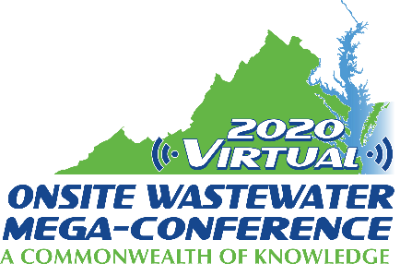

Mini-Track Session Descriptions
2020 Virtual Onsite Wastewater Mega-Conference

Regulation in Virginia
Monday, November 16, 2020 – 2:00 pm – 4:00 pm

Identifying Wastewater Infrastructure Needs for the Commonwealth (30 min.)
Presenter: Lance Gregory
The purpose of this presentation is to share information on the Virginia Department of Health's work with Wastewater Infrastructure Workgroup to identify community and individual wastewater needs throughout the Commonwealth. This includes work with the Virginia Institute of Marina Science to develop unique tools to model the location of suspected areas with wastewater infrastructure needs.

Session title: Virginia Onsite Sewage System Professionals Licensing Updates (30 min.)
Presenter: Trisha Henshaw
The Virginia Board for Waterworks and Wastewater Works Operators and Onsite Sewage System Professionals licenses onsite soil evaluators, onsite septic system inspectors, and onsite septic system operators. The proposed presentation would provide important licensing and examination updates, information regarding recent Board and agency guidance affecting licensees, as well as an overview on expected future actions impacting licensees.

Session title: Department of Health - State Program Update (1 hour)
Presenter: Lance Gregory
The purpose of this presentation is to provide participants with a statewide programmatic update, to include updates on legislative actions from the 2020 General Assembly session (House Bill 1266), progress on revisions to the Sewage Handling and Disposal Regulations, and progress on the revision to the Private Well Regulations. [This presentation was requested by VOWRA].

