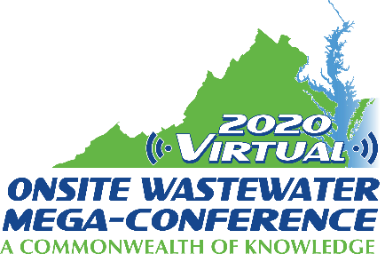

Mini-Track Session Descriptions
2020 Virtual Onsite Wastewater Mega-Conference

Regulatory Issues:
Monday, November 16, 2020 – 2:00 pm – 4:00 pm

Session title: Property Transfer Evaluations in New Mexico since 2005, Managing the Process and Changes; (The Good, the Bad and the Ugly) (1 hour)
Presenter: Michael Broussard
Property transfer evaluations were enacted September 2005 in New Mexico with realtors and installers support. Evaluations have proven to be the most significant measure to improve onsite wastewater compliance since regulatory inception. The process evolved over the years defining regulatory authority involvement. Evaluations drive most permitted modifications and leads to the discovery of more unpermitted systems than the department could have identified otherwise. Transfer evaluations identify more illegal systems including cesspools in the most unlikely places as well as serious threats to the environment. Installers have praised it, some realtors have questioned it but, most have learned to embrace it. Education and training have proven to be tremendously helpful in alleviating disputes. As training professionals begin to train real estate professionals the report's value has significantly improved, and the contentious nature of the contents have decreased. Training department staff and evaluators has also proven to be very beneficial in reducing disputes. Despite all the efforts in refining the process and training we still see challenges. The keys to controlling or managing the process are the evaluation form, the professional and staff training, and developing FAQs to address challenges. The department looks forward to working with key stakeholders, such as realtors and installers to achieve even greater property transfer evaluation enhancements.

Session title: Wastewater Islands and Onsite O&M (1 hour)
Presenter: Danna Revis
The phrase "wastewater island" refers to an area where sewer is not available and there are additional challenges for homeowners who need options for sewage disposal. In addition to finding funding for new systems, many systems installed in these areas require advanced operation and maintenance to function reliably. How can we bridge the gap among low-income homeowners, private maintenance providers and regulatory requirements for maintenance? The answer is funding, but how can we provide the funding and assure it goes to the proper purpose?

