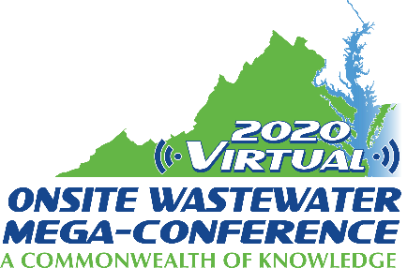

Mini-Track Session Descriptions
2020 Virtual Onsite Wastewater Mega-Conference

Reuse Technology
Tuesday, November 17, 2020 – 2:00 pm – 4:00 pm

Session title: Fenner Nature Center Wastewater Treatment and Re-Use Project (1 hour)
Presenter: Larry Stephens
The average person in the U.S. spends much of their lifetime away from home using public restrooms. We know from experience that about 80% of the water used in public restrooms is used to flush wastes. We typically treat all of our water to potable water standards to be used for all purposes. If wastewater is captured and treated at or near the point of use, that water can be re-used for flushing toilets and urinals saving significant infrastructure and energy costs. Manufacturers of onsite wastewater treatment products today have developed almost an endless list of treatment technologies that can be used to highly treat wastewater to be clear and odorless resembling potable water. Fenner Nature Center in Lansing, MI was building a new environmental education building and needed an onsite wastewater system. The nature center has thousands of visitors every year, including 12,000+ school-age children. The construction of the new building gave our onsite industry a chance to create a wastewater treatment and reuse system that could be incorporated into the environmental education goals of the Nature Center. Onsite system manufacturers, local contractors and MOWRA members donated most of the materials and labor to construct the system. The system came on line in Dec., 2019.

Session title: Reuse Comes to On-Site Systems (1 hour)
Presenter: Gary MacConnell
Reuse wastewater systems have been common for municipal and larger community systems. However, reuse systems for small systems including single family homes have been less common. With advancement in technologies, it is now possible for small systems to be permitted, installed, and operated successfully. One single family on-site system in North Carolina was modified using a recirculating media filter to meet State regulatory requirements for re-use. The challenges, design modifications, operation and success of the system are presented in detail as a case study.

