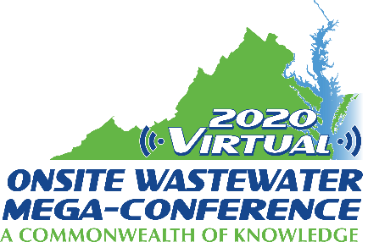

Mini-Track Session Descriptions
2020 Virtual Onsite Wastewater Mega-Conference

Standards and Measures
Wednesday, November 18, 2020 – 2:00 pm – 4:00 pm

Session title: In-situ Liquid Storage Capacity Measurement of Subsurface Wastewater Absorption System Products (30 min.)
Presenter: Philip Brown
A method is presented for measuring in-situ liquid storage capacity of subsurface wastewater infiltration system (SWIS) products. These products vary in composition, geometry, and porosity, but all function as a conduit for effluent flow from the septic tank to and through a trench allowing infiltration into the soil. SWIS's also provide temporary liquid storage; necessary when discharge exceeds infiltration rate, and important during periods of soil saturation. Many regulations pertaining to storage volume are based on traditional gravel-pipe systems. Storage comparisons between alternative products and gravel have been difficult as no standard method exists. Some products have been evaluated under field conditions; others under theoretical or ideal conditions. Protocols developed in this study could serve as a common, accurate basis for comparisons. A 3 ft deep trench was excavated and leveled. Markers were attached to products indicating invert and full-volume. Products were enclosed in plastic, put in a trench, and covered with soil. A pipe extended to the surface allowing metered water additions and determination of system capacity. Four plastic chambers, three expanded polystyrene (ESP) products, two multipipe systems, and a gravel-pipe system were evaluated. Three plastic chambers stored 100-130%, multipipe systems held 80-90%, and ESP bundles held 75% of the standard. These differences illustrate the need for a standard protocol for measuring storage volume.

Session title: A study on BODs (30 min.)
Presenter: Jim King
This presentation is a study of various common household waste and what is the corresponding BOD strength. We will compare 15 to twenty household items to include, soda, coffee, juice, ice cream and other easily liquefied material. The current list: Coke Soda , Mountain Dew Soda , Red Bull Soda , Budweiser Light Beer , Tree House Haze Beer, 2% Milk , Light Cream, Orange Juice , Wine , Ice Cream , Oil, Coffee Black, Coffee with Cream and Sugar. The goal is to use items that are found thought the US so this test can be duplicated anywhere. Further research will investigate the impact on the use of these items on a daily basis.

Session title: Panel Discussion - NSF Standards- Past, Present and Future (1 hour)
Presenter: Ron Suchecki Panel Chair
A panel of NSF Joint Committee Members, representing Industry, Regulatory and User categories of the NSF Joint Committee on Wastewater will be leading a discussion on NSF Standards. During this presentation, we will discuss the results of a nation-wide survey on the Standard 40, and provide an overview for Standard 40, 41, 285, 350 and other lesser known and developing standards. In addition to the above topics, there will be updates on the changes we have been incrementally making (foreword, upsizing criteria as examples) a discussion of the current obstacles (in-ground Standard 40's, High Strength Standard development), and the direction things are going (ultra-low use, split gray/blackwater systems) and have time for feedback and interaction with the audience.

