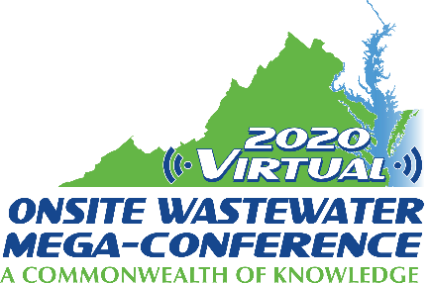

Mini-Track Session Descriptions
2020 Virtual Onsite Wastewater Mega-Conference

Tanks and More
Wednesday, November 18, 2020 – 9:00 am – 12:00 pm

Session title: Understanding Tank Buoyancy (1 hour)
Presenter: Kayla Hanson
There are many forces at work on underground wastewater treatment structures. Buoyancy is one of those forces, and can be significant enough to lift a tank out of the ground. Buoyancy is an essential consideration of underground tank design. During this presentation, we will first explore the concept of buoyancy to understand how it works. We will demonstrate the calculation of buoyant forces on a typical precast concrete septic tank under different conditions. We will then talk about countermeasures that can be taken to ensure the buoyant force never exceeds the downward forces. This is essential information for those who design, manufacture, install, regulate, and inspect underground wastewater structures.

Session title: Keeping What's In In and What's Out Out (1 hour)
Presenter: Kayla Hanson
Strong, durable, watertight tanks are an essential component of every onsite wastewater system. To achieve effective, efficient, and reliable treatment, tanks must be designed to excel in the conditions they'll be exposed to during their service life. Watertightness is a characteristic that depends on the quality of the concrete, the tank's joints and sealants, the pipe connections, and the riser sections. During this session we will examine each of these crucial areas and discuss what goes into making precast concrete tanks watertight. We will also review what mistakes could lead to leaking and what manufacturers and installers are doing, or should be doing, to avoid these issues. We will also touch on some basics of concrete, including its ingredients, how and why concrete hardens, and how it behaves over time. Lastly, we will discuss watertightness testing by the hydrostatic method and the vacuum method.

Session title: Wastewater Treatment Myths (1 hour)
Presenter: Allison Blodig
Some of the mistakes that are made in designing treatment systems are based on a few common misconceptions or myths about wastewater treatment. This presentation will discuss these misconceptions or myths and how they can make the difference in a system's long term performance.

