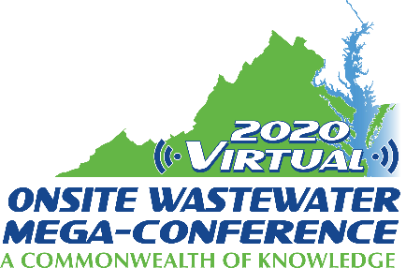

Mini-Track Session Descriptions
2020 Virtual Onsite Wastewater Mega-Conference

CDL and Vac Truck Training
Tuesday, November 17, 2020 – 9:00 am – 12:00 pm

Session title: Vaccuum Truck Technician Training (2 hours)
Presenter: Bruce Fox
The Vacuum Truck Technician training course is targeted to those that own or operate a vacuum truck which is used to clean septic tanks, aerobic treatment units, holding tanks or grease traps. It is directed specifically at owners and employees who may just be starting in business and need a good solid base of information to work with to perform their daily tasks. At the same time this training provides a good refresher and overview for even experienced operators.
Topics of instruction include:
- Materials to pump and avoid
- Government regulations
- Truck equipment and components
- Drive and Control mechanisms
- Basic and advanced pump out skills and procedures
- Loading and unloading
- Safety and emergency response plans
- Customer interaction and education
- Reasons to manage these materials
- Basic science of vacuum and pressurization
- Pumps
- Basic Pump Truck Operation
- Manifests and reports
Session title: CDL and DOT requirements for pre-/post-trip inspection (1 hour)
Presenter: Fred Yuhasz
This session will discuss the changes in CDL regulations with regard to completing pre-/post-trip inspections. What the business owner needs to know about the process and any liability issues with these inspections. It will also discuss what a new or applicant CDL individual will need to know to be able to pass the CDL exam. In addition the topic of how to deal with road side inspections will be discussed.

