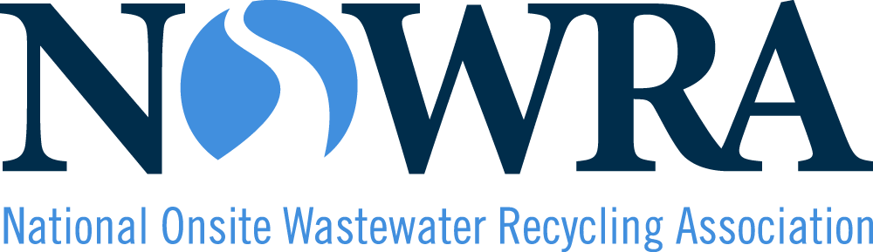

Program Evaluation
Homeowner Workshop for Maintaining
Onsite Wastewater Treatment Systems

Property Owner Evaluation

Name (optional): _________________

Demographics (optional):
These questions are optional and your answers will be kept private. We would like you to tell us your race, ethnicity, and gender so that we can find and address differences in access to training and other services in rural communities.

Q1. Race/Ethnicity - Select all that apply
- American Indian or Alaska Native
- Asian
- Black or of African descent
- Hispanic, Latino, or of Spanish origin
- Middle Eastern or North African
- Native Hawaiian or Pacific Islander
- White
- Prefer Not to Answer
- Prefer to Self-Describe – See Below
Self-Describe:_________________________________

Q2. Gender - Select all that apply
- Female
- Male
- Non-binary
- Prefer Not to Answer
- Prefer to Self-Describe – See Below
Self-Describe:_________________________________

Q3: Role (circle all that apply):

homeowner (with a septic system) administrator/manager board/council member

government official septic system professional realtor

Q4: State you live in: __________________________________________

Q5. How did you hear about this training? (select all that apply)
- Mail
- Phone
- Website
- Social media (Facebook, twitter …)
- Supervisor or colleague
- E-mail announcement
- State or federal agency
- Other: _____________________________________________

Train Course Evaluation
Overall Evaluation (circle the number that best matches your experience):

a. Objectives of this course were:
Clearly Evident 5 4 3 2 1 Not Evident

b. Power points presenting the material were:
Excellent 5 4 3 2 1 Poor

c. Videos and photos made the course more fun and engaging:
True 5 4 3 2 1 False

d. Organization and presentation of material was:
Excellent 5 4 3 2 1 Poor

e. The User Manual was clearly written and organized:
Excellent 5 4 3 2 1 Poor

f. My expectations were:
All Met 5 4 3 2 1 Not Met

g. Overall, I would consider this program:
Excellent 5 4 3 2 1 Poor

3. Would you recommend this course to another homeowner? (Circle your response)

Yes No

4. For each item listed below, please indicate your intentions to adopt the following practice(s), or indicate whether you have already adopted them (place an X in the box that best matches).

Practice | Will not adopt | Undecided | Probably will adopt | Adopted already | Tried it before; discontinued application
Have your septic tank pumped on a regular basis
Spread out water usage throughout the week
Prevent heavy vehicles from driving over the soil treatment area
Put solid waste in the trash can rather than down the drain
Take left-over medications to appropriate drop-off locations

