EPA Decentralized Wastewater MOU Partnership SepticSmart Week 2021:
How-To Guide for Proclamations

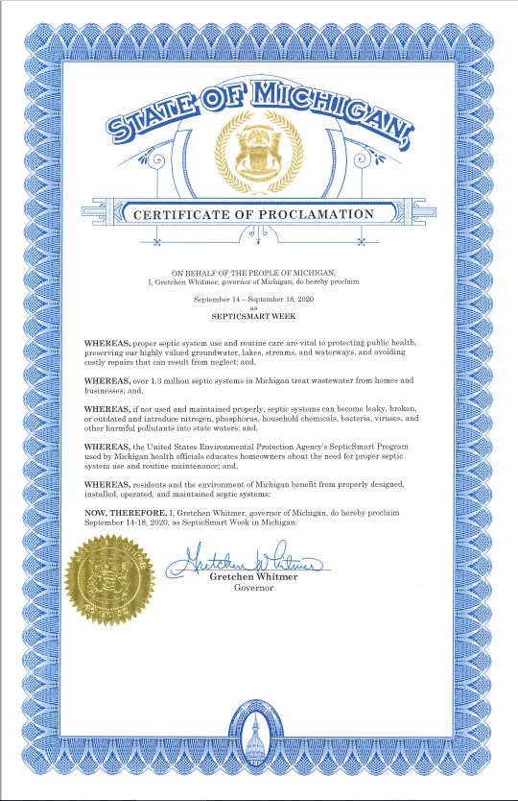
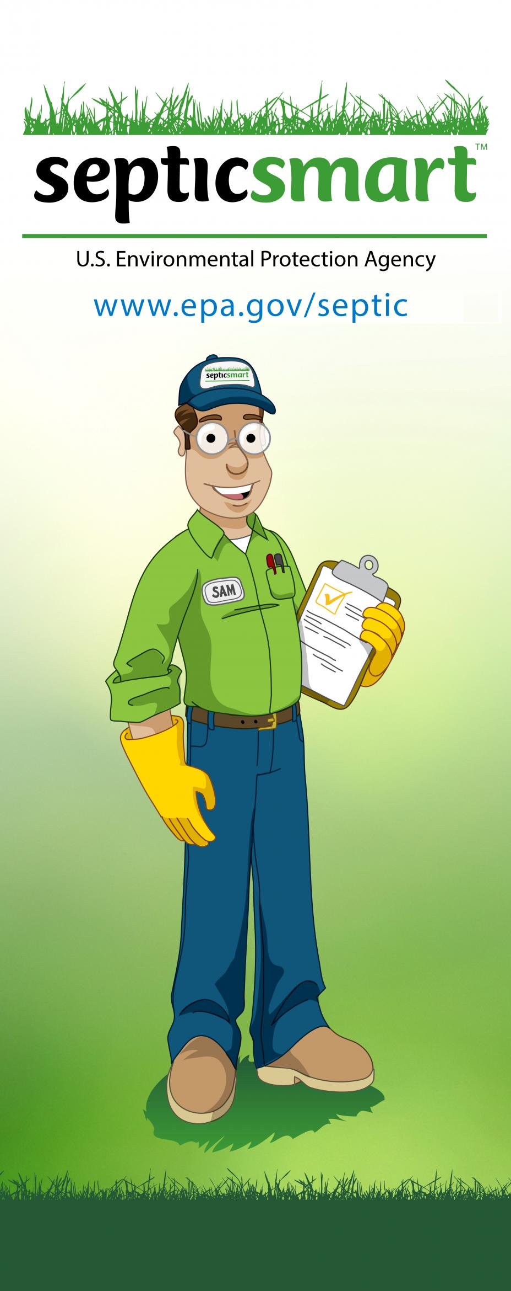

Contents
Proclamations for Decentralized Wastewater MOU Partners 3
Step 1: Access Proclamation 3
Step 2: Download and Customize 3
Step 3: Confirm Signatory 4
Step 4: Export and Share 5
Step 5: Social Media, Press Releases, Listservs, and Newsletters 5
Step 6: Encourage Others 6
Step 7: Plan Ahead 6
Proclamations for Governors and Mayors 8
Step 1: Connect with Representatives 8
Step 2: Follow Up and Follow Up 8
Step 3: Share via Social Media 9
Step 4: Share with EPA 10
Additional Examples 10

Proclamations for Decentralized Wastewater MOU Partners

Step 1: Access Proclamation
Access the SepticSmart Week Proclamation template for Decentralized Wastewater MOU Partners. The template is located on the Septic Systems Outreach Toolkit webpage of the EPA website.

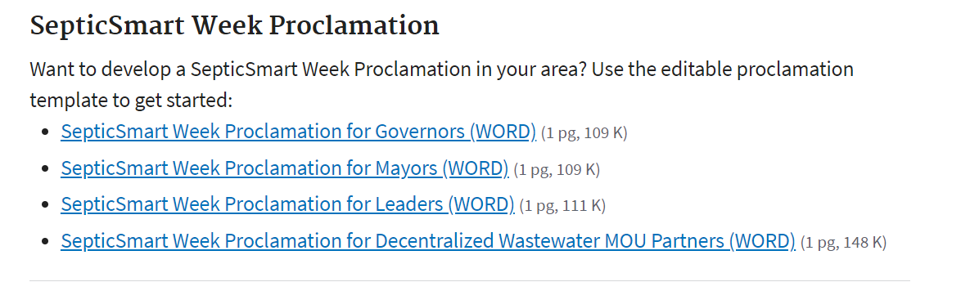

Step 2: Download and Customize
Download the Microsoft Word document, and then fill in the SepticSmart Week Proclamation template for Decentralized Wastewater MOU Partners with the appropriate information. The red texts indicate places in the document that must be customized to your organization, organization’s logo or letterhead, organization’s signatory, and current date and year.

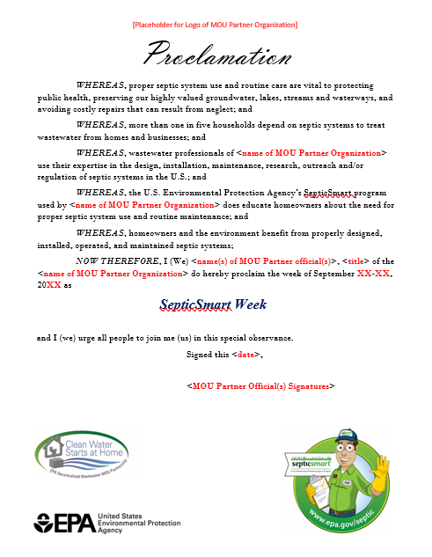

Step 3: Confirm Signatory
Determine or confirm your organization’s signatory and obtain his or her signature. The selection of the signatory is decided on by each MOU partner. The signature can be digital or electronic, or physically printed and signed.

There are many ways to insert an electronic signature. In a Microsoft Word document, you can follow these three options to insert a signature. In an Adobe PDF, you can create and insert an electronic signature using the Fill and Sign option. Note: If you plan on signing the proclamation in an Adobe PDF, be sure to complete Step 2 and Step 4 beforehand. There are also external applications, such as DocuSign, that allow you to upload a document and insert a signature.

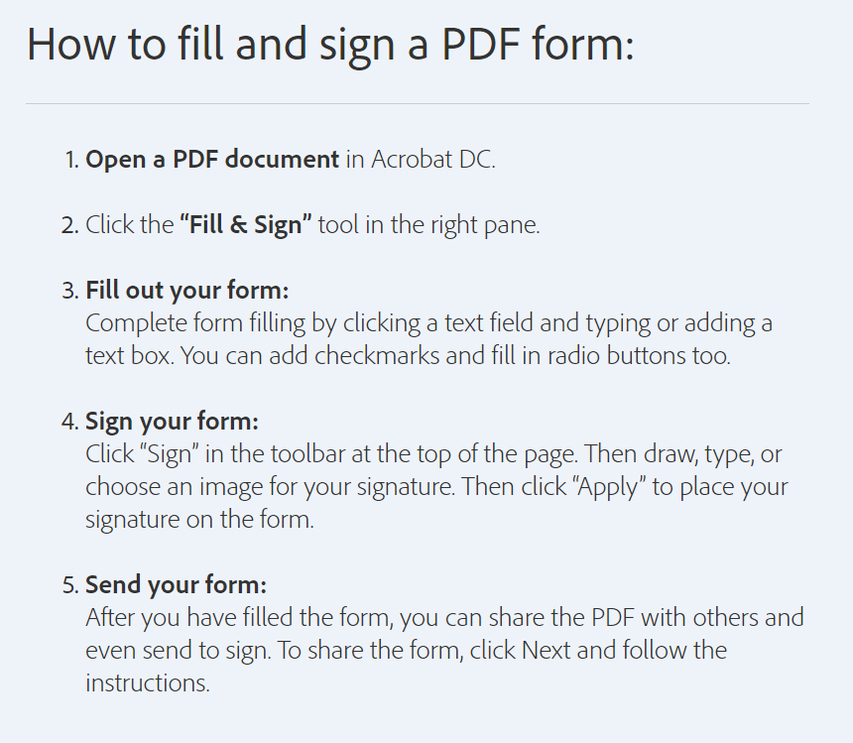

Step 4: Export and Share
Export your proclamation to PDF or scan your proclamation to a PDF, and then share the document on your organization’s website and social media accounts.

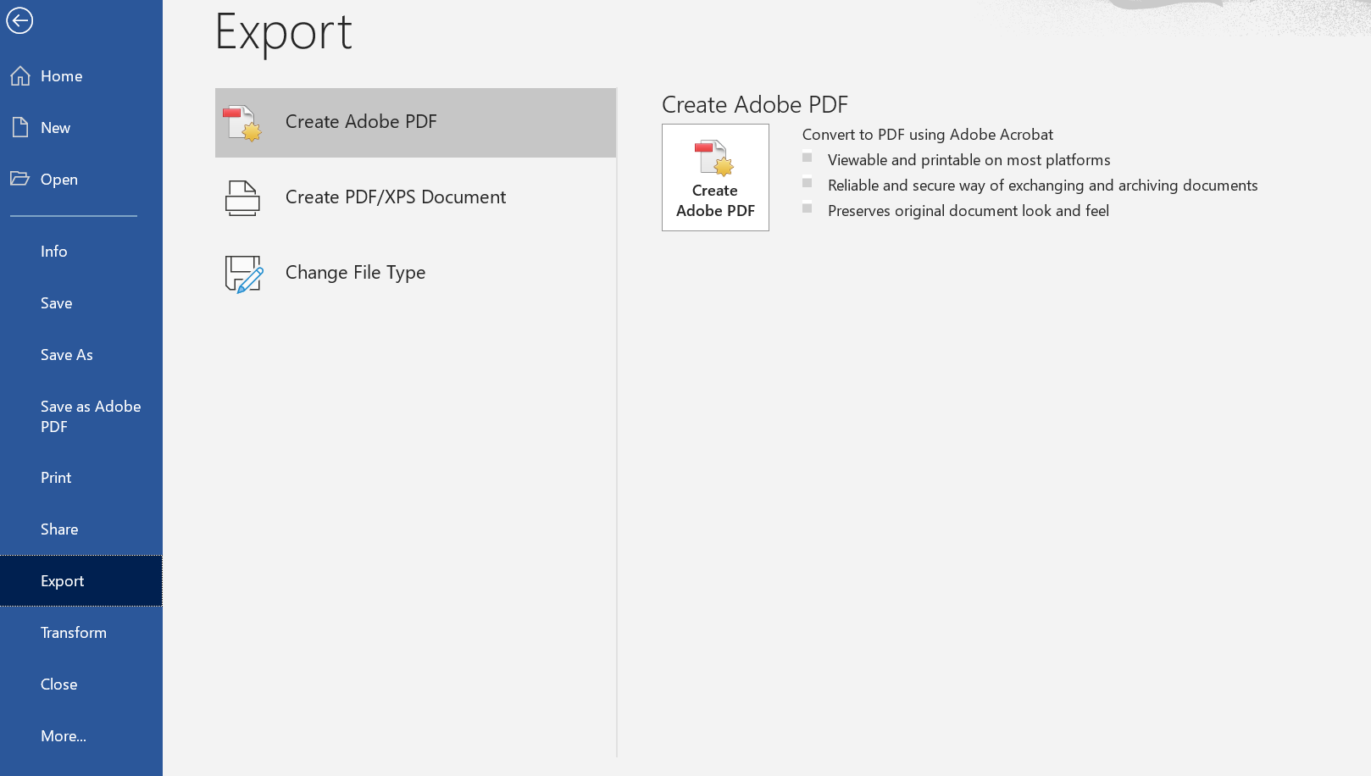

To share your finished proclamation, follow these steps: 1) Send the PDF via email the EPA Decentralized Wastewater Program team, 2) Share the PDF with your organization’s web master or manager with a note asking them to publish it on your organization’s website, and 3) If available, share the PDF and/or link to your organization’s communication staff.

Step 5: Social Media, Press Releases, Listservs, and Newsletters
Post the proclamation to social media, listservs, and newsletters. The two most common ways to share your proclamation on social media are by attaching it as an image or linking to it in the text. When doing this, please include the MOU Partnership official hashtag (#SepticSmart), so that your organization and EPA can track its total reach and engagement. In addition, send the proclamation to listserv managers or communications staff who oversee listserv and newsletter content. Communications staff should also be encouraged to write a corresponding press release to post on your website. Once your organization has completed this step, let the MOU Partnership know.

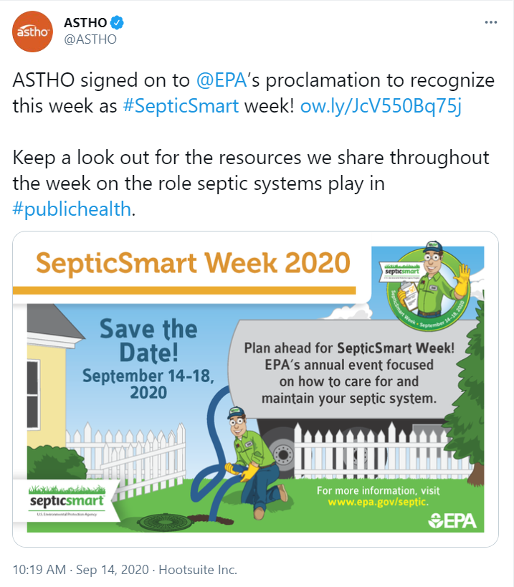

Step 6: Encourage Others
Encourage your networks to do the same. The Septic Systems Outreach Toolkit webpage of the EPA website includes templates for not just MOU partners, but also for Governors, Mayors, and Leaders. Governor’s and mayor’s offices may require extra time to approve and complete a proclamation, so be sure to remind them at least two months in advance. The Leaders template is purposefully broader. This can be customized for all sorts of decentralized wastewater champions within and not limited to community organizations, state and local health and/or environment departments, academia, and local septic system installers and pumpers.

Step 7: Plan Ahead
Review the proclamation timeline for additional planning help. The 2020 SepticSmart Week Social Media includes a planning timeline for proclamations. Customize this timeline to fit your organization’s needs and capabilities.

Monthly Planning Guide to a SepticSmart Week Proclamation

MONTH | STEPS | IMPORTANT NOTES
May | - Begin gathering information  - Create a timeline | - Start early!
June | - Identify any established procedures around securing a proclamation  - Ensure you have leadership support and make sure that is communicated in each step  - Develop the wording for the proclamation (see EPA sample proclamations)  - Draft memo from agency head to your state’s appointed health official (i.e. Secretary of Health, Surgeon General, etc.)  - Draft memo from Health Official to Governor’s Office | - Save email from your leadership approving initiative as your Governor’s Office may ask for it  - Make sure wording is short and to the point  - Explain how it will benefit communities  - Make sure the proclamation is in Microsoft Word for easy editing  - Write the Governor’s Proclamation yourself in plain text, without any formatting. This makes it easy for the Governor’s Office to simply use your draft and add on their Governor Proclamation formatting  - Check out examples of previous years’ proclamations (https://www.epa.gov/septic/septicsmart-week-2017-proclamations)
July | - Enlist support from other state/local health departments  - Identify a point person in the process, whether at the State Health Department or Governor’s Office that you can check in with | - Keeping in touch will help you to know the status of your request and if there is anything missing that you need to submit  - Knowing this early on is important so that you do not run out of time to make corrections or additions  - Follow up with emails and phone calls  - Ensure memos are sent from agency head to health official
August | - When you receive your proclamation, SHARE IT! Share it at local events, social media posts and news releases | - The proclamation gets posted on the governor’s webpage, bringing more attention to your cause  - The proclamation adds more weight to your social media posts and increases the chance of it being picked up and shared across wider audiences
September | - Share! Share! Share!  - Measure your impact! | - Metrics matter! As much as possible, identify the impact of your outreach activities.  - Connect with partners to measure impact  - Are calls regarding septic system operation and maintenance increasing?  - Are local health departments seeing an increase in calls?

Proclamations for Governors and Mayors

Step 1: Connect with Representatives
SepticSmart Week proclamation templates are available for more than MOU partners. State governors’ offices and city mayors’ offices can also issue proclamations to indicate their support for state and local decentralized wastewater concerns. Determining who to contact is the first and most important step. Historically, the three most common way to reach these offices has been through 1) direct contact with the governors/mayors’ office, 2) MOU Partnership relationships, and 3) Contact with state and local health and environment departments.

Many MOU partners have state and local affiliates that include wastewater professionals, technicians, installers, and regulators. For example, NOWRA, SORA, NAWT, ASTHO, and more have members and representatives in nearly every state. Many of them work for or have contacts with their state and local health and environment departments. Leadership of health and environment departments routinely interact with governor’s and mayor’s offices and will know how to put state and local proclamations on their radar.

Step 2: Follow Up and Follow Up
Any entity can issue a state or local proclamation. A broad variety of organizations have previously issued proclamations. If there is a new administration that does not know how to fill out and customize a proclamation, direct them to Steps 1, 2, 3 and 4 in the Proclamations for MOU partners (above). One difference between MOU partner proclamations and state and local proclamations are the use of seals, logos, and official stamps. Encourage the representative to customize to how they see fit.

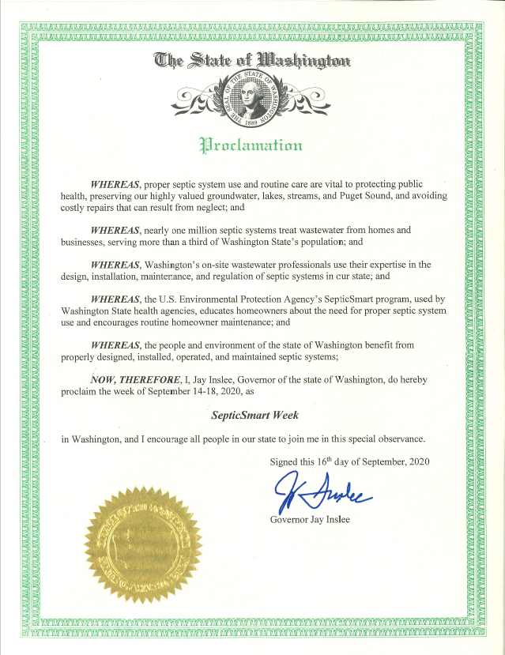

Step 3: Share via Social Media
Promote their state and local proclamation. The best way to do this is by liking, retweeting, or commenting on their social media posts. This amplifies their message and shares it with a whole new audience. If even a small number of individuals promote these posts, its spread is exponential.

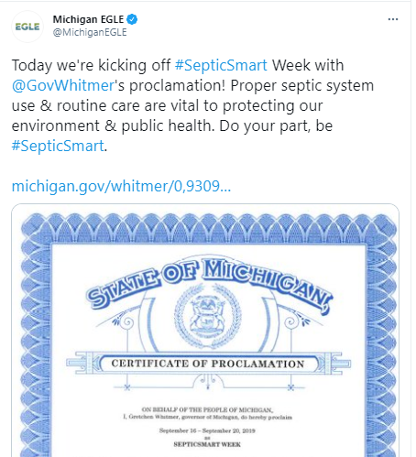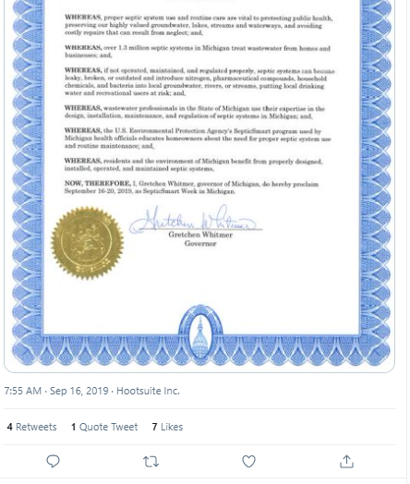

Step 4: Share with EPA
Proclamations are an important indicator of outreach and awareness for the EPA Decentralized Wastewater Program. EPA tracks all proclamations and submits them to EPA leadership. Please let the EPA know if you have worked with a state or locality or if you have come across a state or locality’s proclamation. They can be sent via email to DecentralizedMOU@epa.gov.

Additional Examples
